**4 Agency night- Art Therapy**

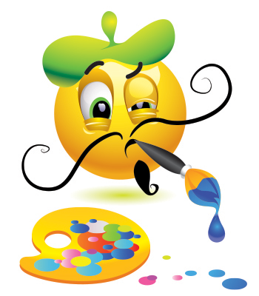

5 Taco Tuesday-Healthy Choices

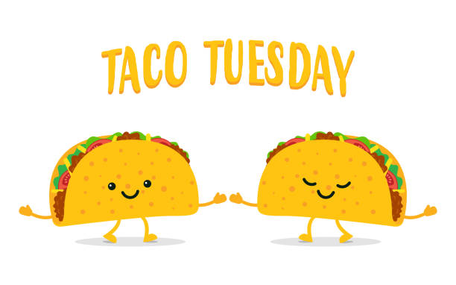

6 LGBT-DNINNER



**8** BOYS TO MENDINNER

Feeling Check 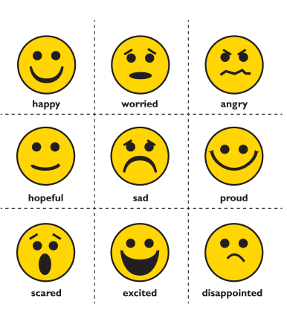

7 ROAD RECOVERY & TRAX- Ladies 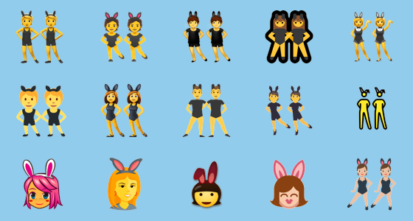





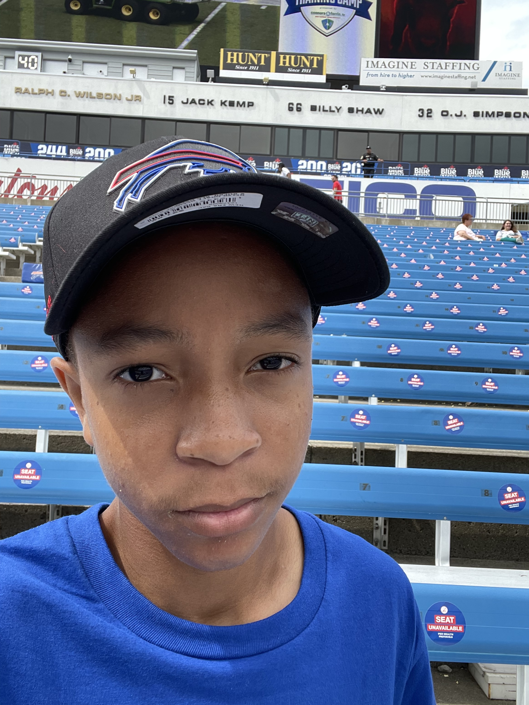

1 BOYS TO MEN DINNER

Pool Tournament ol Tournament

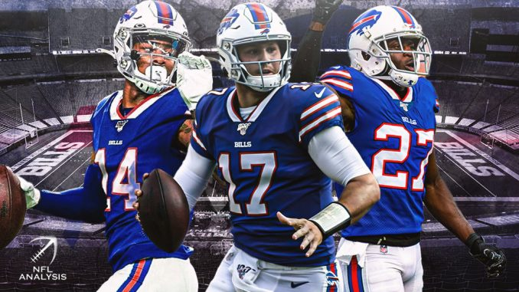

11 **Agency night- Art Therapy**  

12 Taco Tuesday-Food Prep

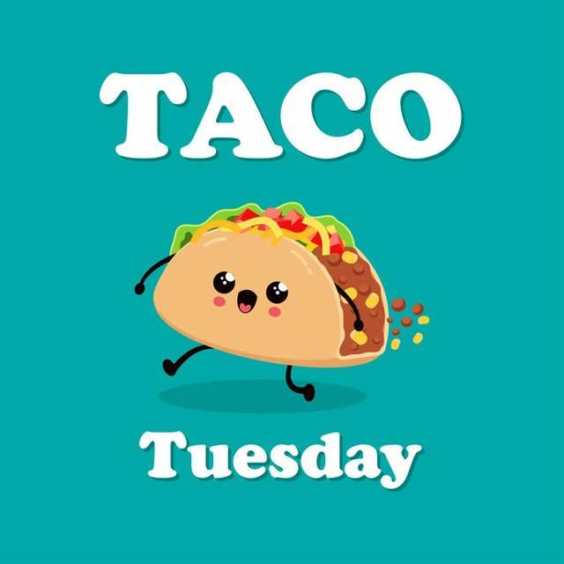

13  **LGBTQA-Peer Support****+ Dinner.**

15 BOYS TO MEN DINNER

Poetry Night 

14 ROAD RECOVERY & TRAX -Ladies 

18 Agency night- Art Therapy



19 Taco Tuesday-Table Etiquette

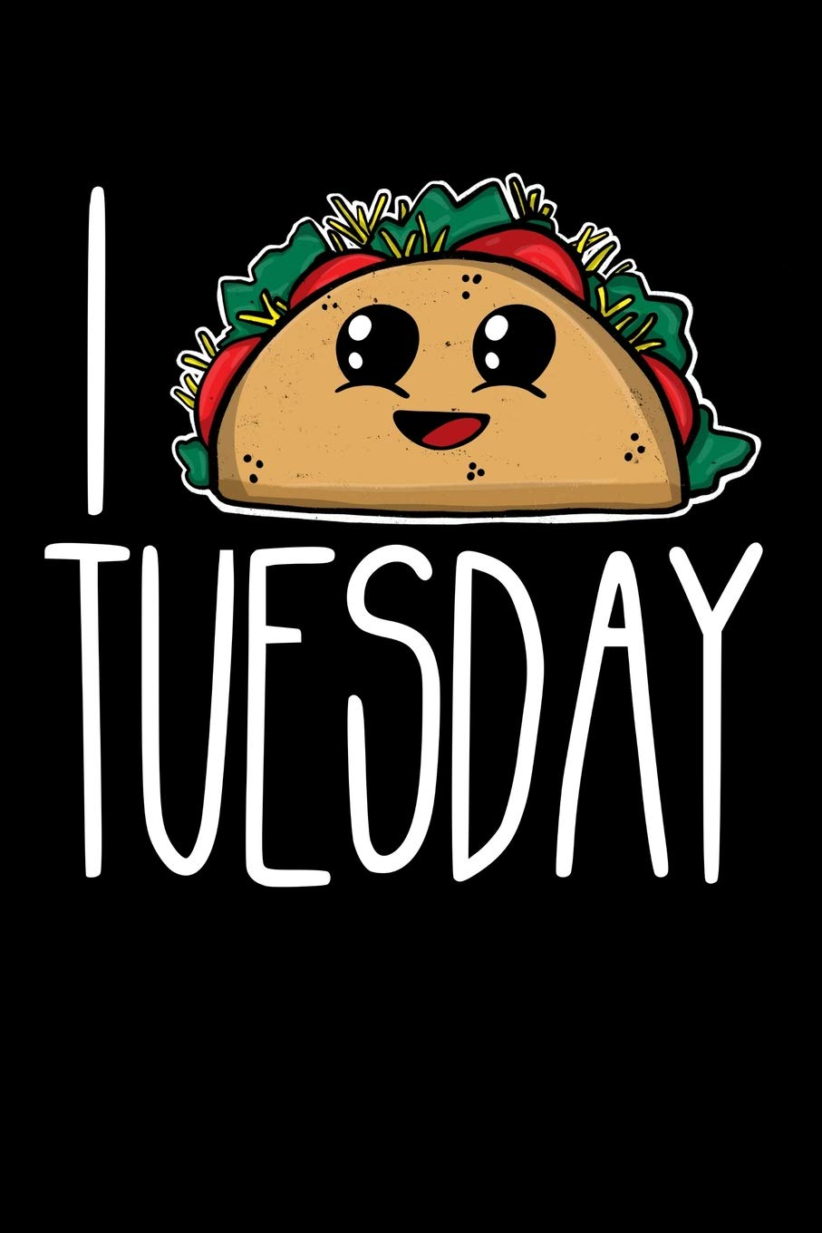

20 **LGBTQA+ Dinner**

**Pease HUB**



**22** BOYS TO MEN DINNER

**Ted TALKS Feelings check**



21 ROAD RECOVERY & Trax –LADIES NIGHT

**25 Agency night- Art Therapy**



26 Taco Tuesday –Healthy -Choices

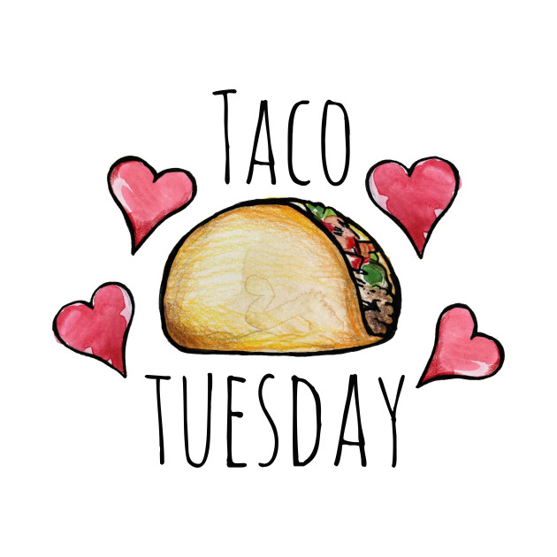

27 **LGBTQA+ Guest Speaker JOB SEARCH**



29 Boys to Men dinnerBingo Night 

28 ROAD RECOVERY & TRAX -Ladies 

**Monday**

**Tuesday**

**Wednesday**

**Friday**

**Thursday**

Clubhouse Buffalo

October 2021

66 Englewood Ave, Buffalo, NY 14214

(716) 832-2141 ext. 212, 217 or, 249

**Hours for Ages 16-21 years of age**

**Monday to Friday 3 to 9pm**