7 **Boys to Men Dinner**

***LABOR DAY***

**CLUB HOUSE CLOSED**

8 **Recovery Peer Support**

**Poetry Night**



9  **LGBTQA Dinner**

**Cook Out**

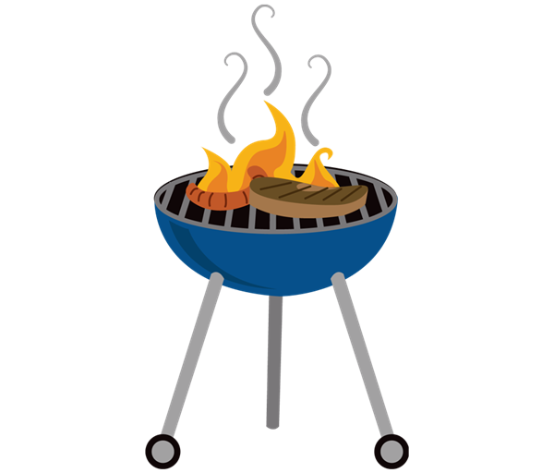

11 **Ladies Night**

**Ice Cream Day**



10

**Educational Peer Tutoring**

*Personal Fitness Day*



**1.**  **Peace HUB**

**Game Night**



**2. LGBTQA Dinner**

**Karaoke Night**



**4 Ladies Night**

**Movie Night**

3 **Nature Walk**

TED TALK



14 **Boys to Men Dinner**

**Painting and Drawing**

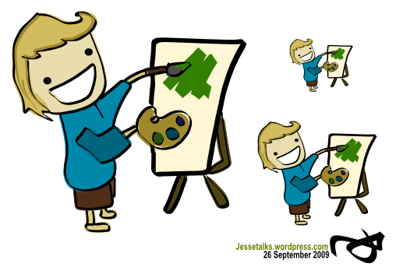

15 TED TALK

**Game Night**

Hispanic Heritage Night

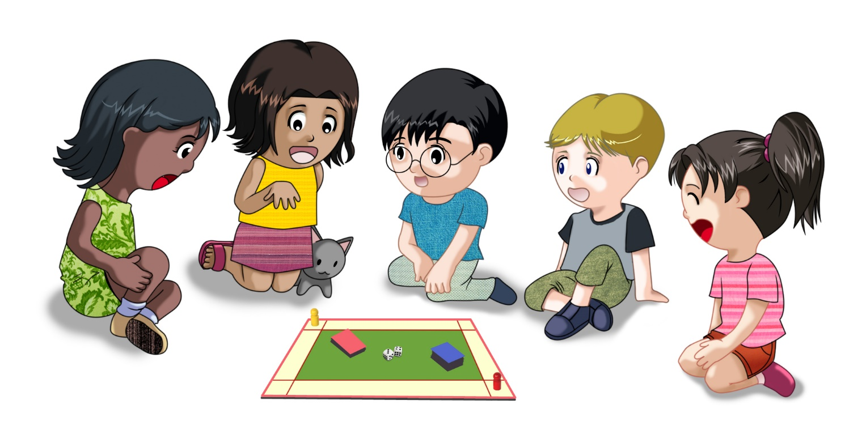

16 **LGBTQA Dinner**

Bring a Family member day



**18 Ladies Night**

***National Cheeseburger Day***

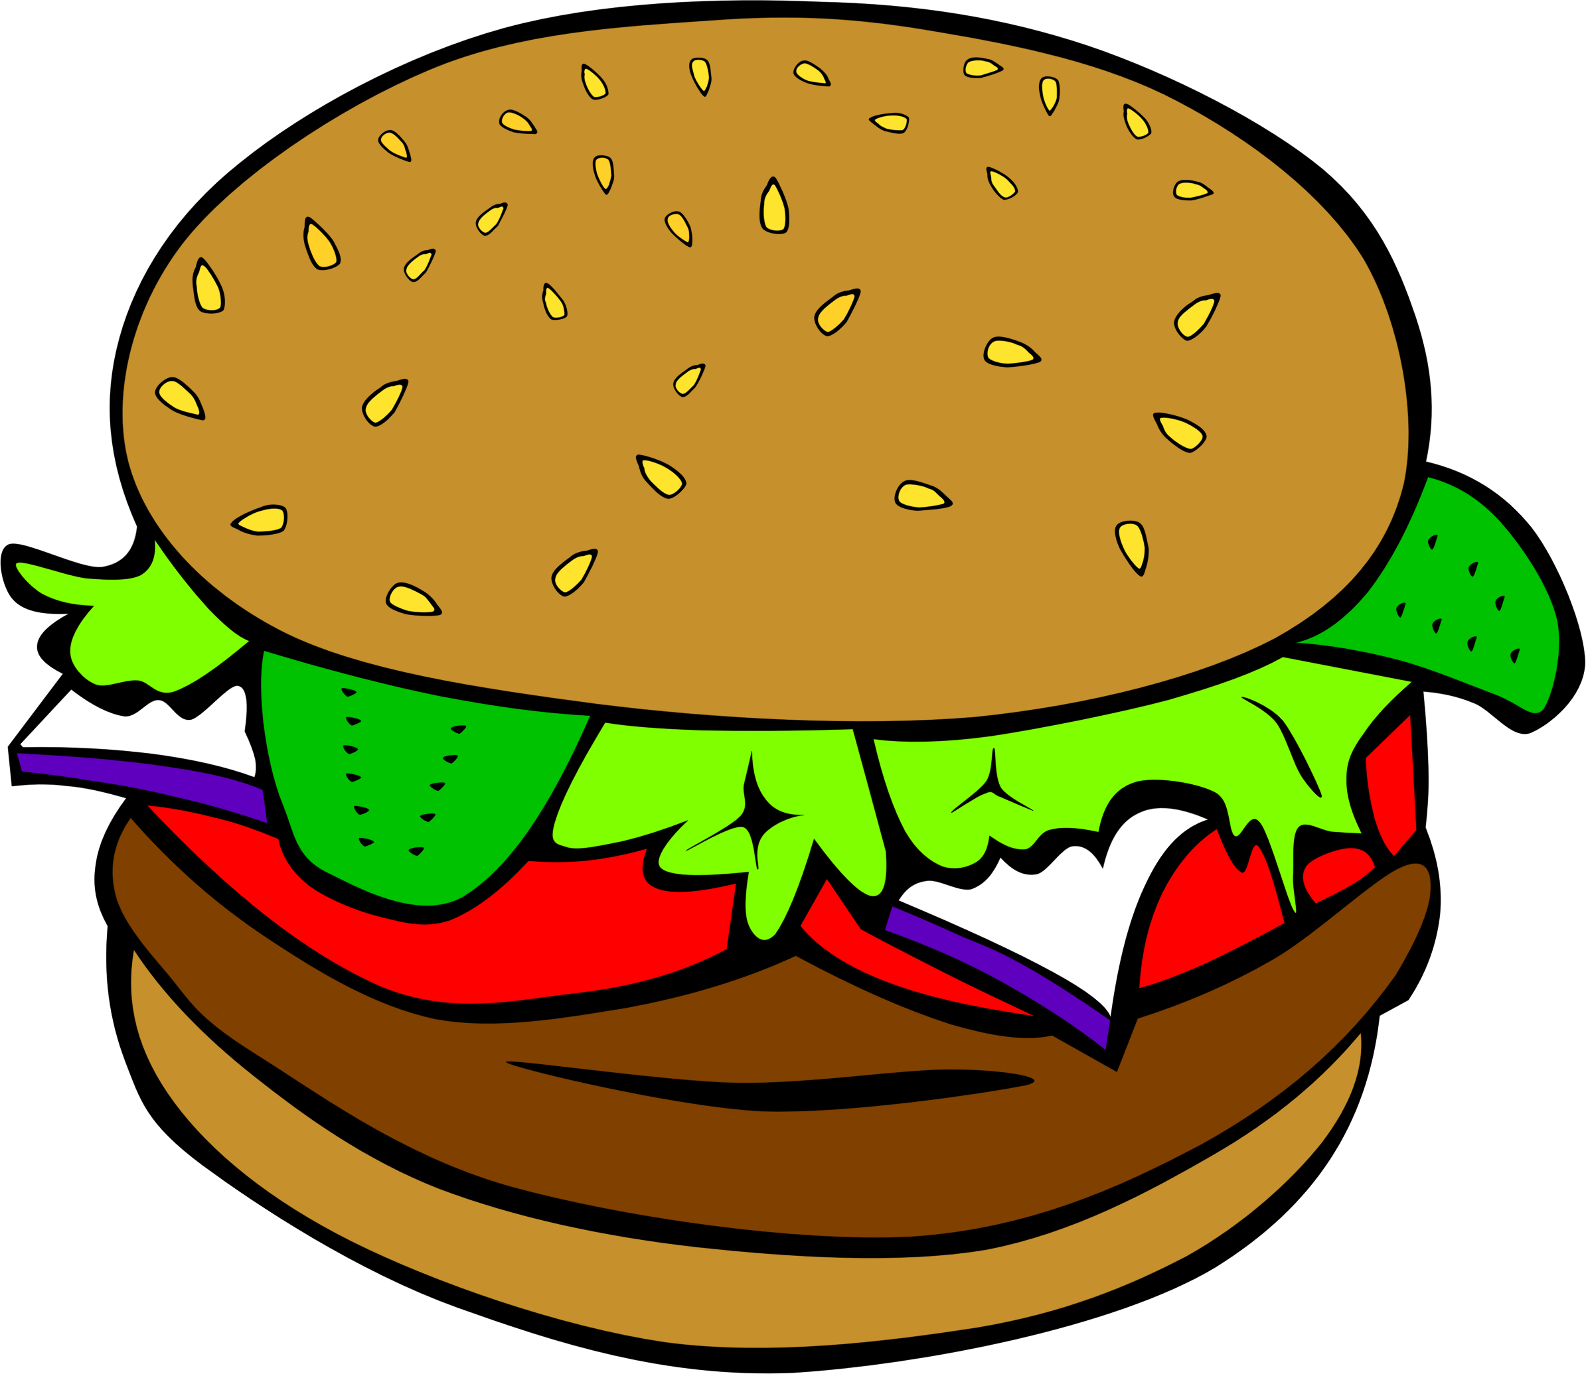

17 **Karaoke Nights**

**Exploring Healthy Relationships**

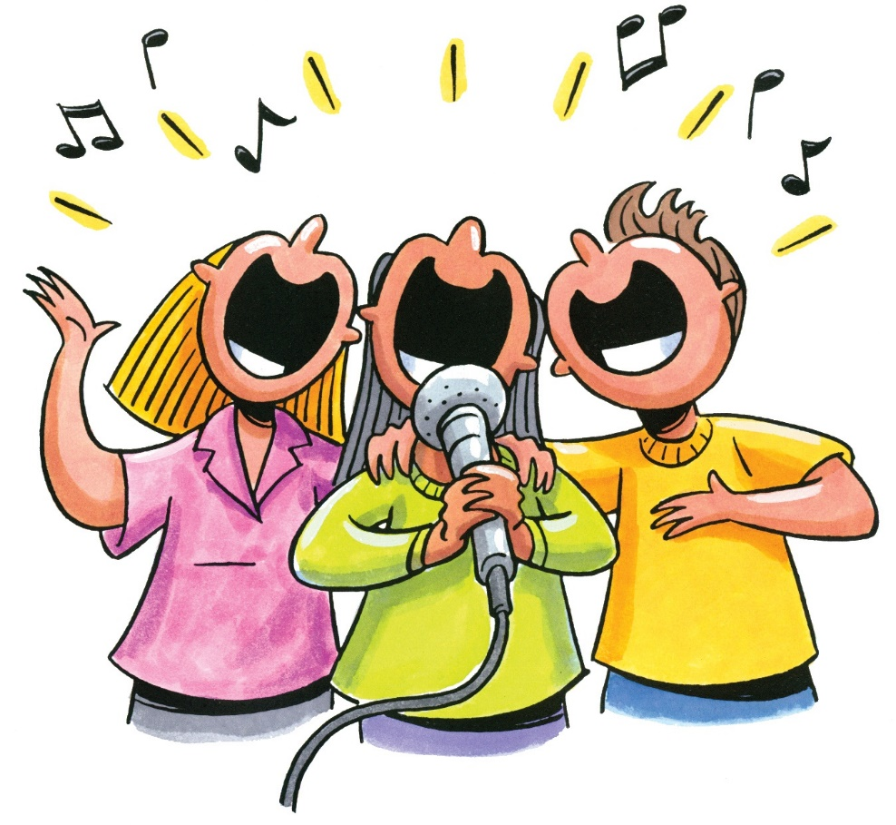

21 **Boys to Men Dinner**

**Dance Party** USA



22 **Virtual Tour Day**

***Autumn begins***

Feelings Check



23 **LGBTQA Dinner**

***Fitness Night***

**

**25 Ladies Night**

**Popcorn and Movie Night**



**24**

**City ART Tour**



28 **Boys to Men Dinner**

**Talk a Walk in the Park Day**

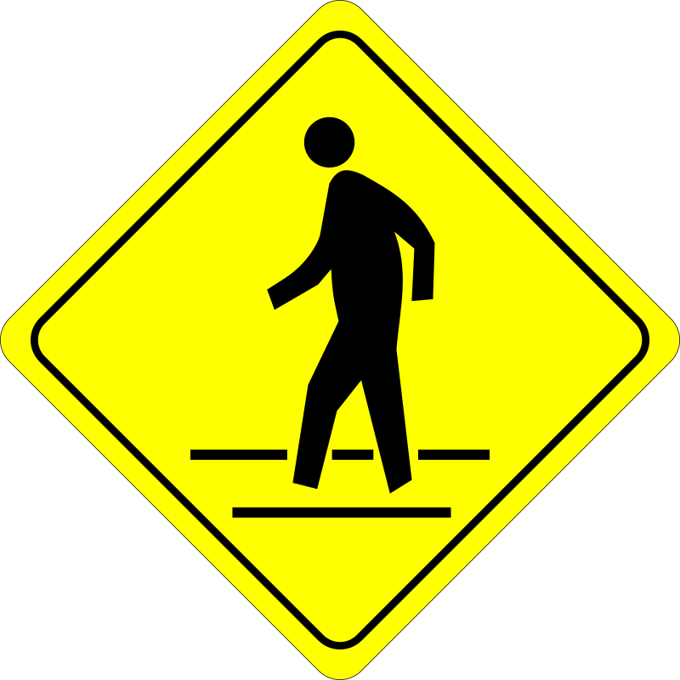

**29 Recovery Peer Support**

**Virtual Tour Day**



30 **LGBTQA Dinner**

**Monthly Birthday Celebration**



**Meals are FREE!!!**

**Dinner will be served nightly.**

**Meals will be safely prepared for you until further notice.**

**Masks must be worn, & will be provided for you if need be.**

**Social Distancing will be in effect.**

**Your safety is IMPORTANT to us!**

**Monday**

**Tuesday**

**Wednesday**

**Friday**

**Thursday**

Clubhouse Buffalo

September, 2020

66 Englewood Ave, Buffalo, NY 14214

(716)832-2141 ext. 212, 217 or, 249

**Hours for Ages 16-20 years of age**

**Monday to Friday 3 to 8pm**