Recovery Happens

Illuminating pathways toward opportunity, possibility, wellness and independence.

###### Restoration Society, Inc., 66 Englewood Avenue, Buffalo, NY 14214

###### [www.rsiwny.org](http://www.rsiwny.org) (716) 832-2141 Fax (716) 832-0021

­––

Recovery Happens

Illuminating pathways toward opportunity, possibility, wellness and independence.

###### Restoration Society, Inc., 66 Englewood Avenue, Buffalo, NY 14214

###### [www.rsiwny.org](http://www.rsiwny.org) (716) 832-2141 Fax (716) 832-0021

July 2020

Volume 12, Issue 7

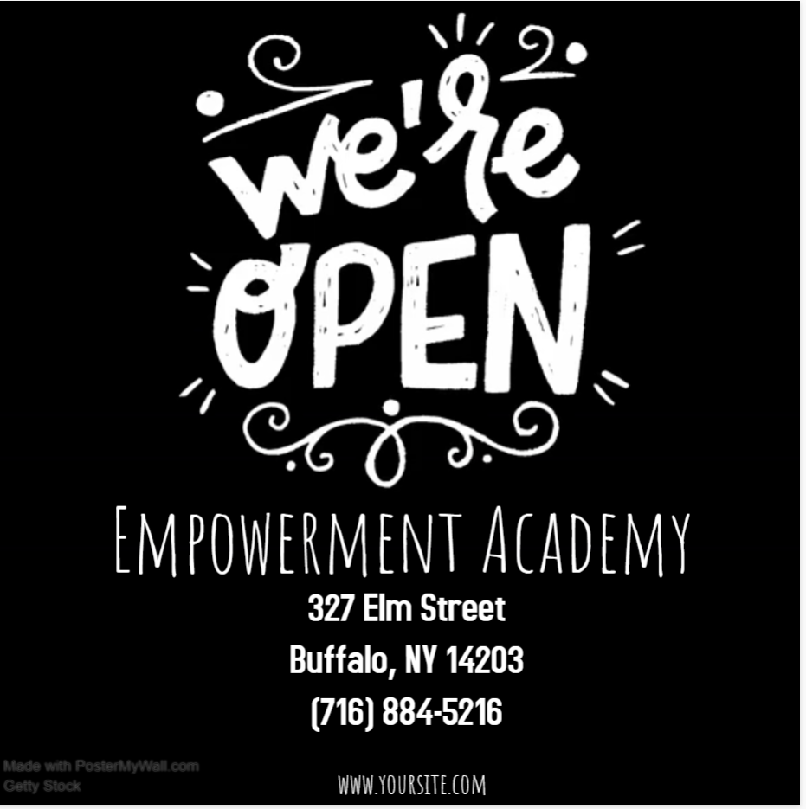

Practice Social Distancing with Us!

Monday – Friday 9am-8:30pm

Saturday & Sunday 9am-1pm

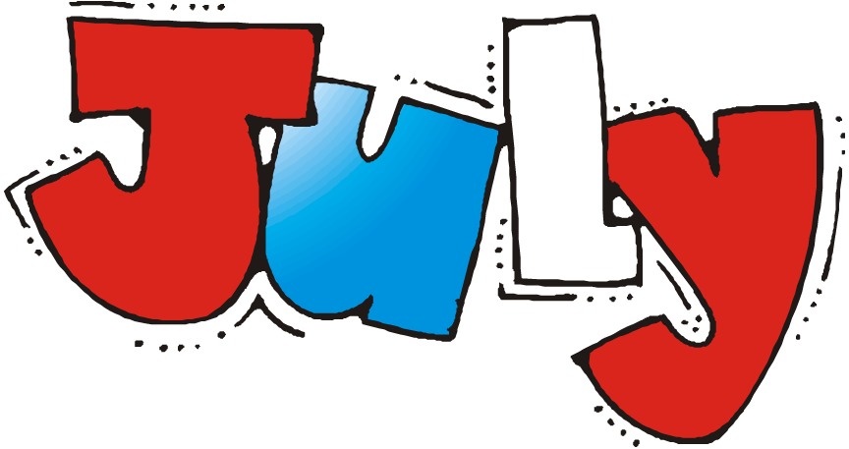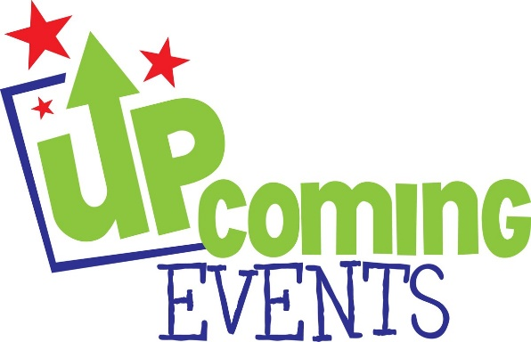

Metro fare collection resumes Monday, June 29.  April Metro Monthly passes are valid through July.

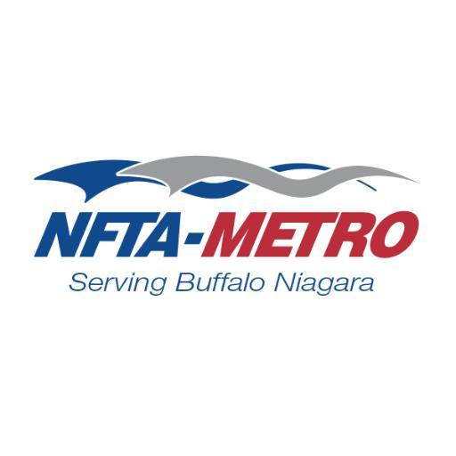

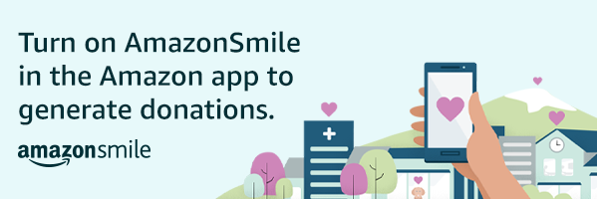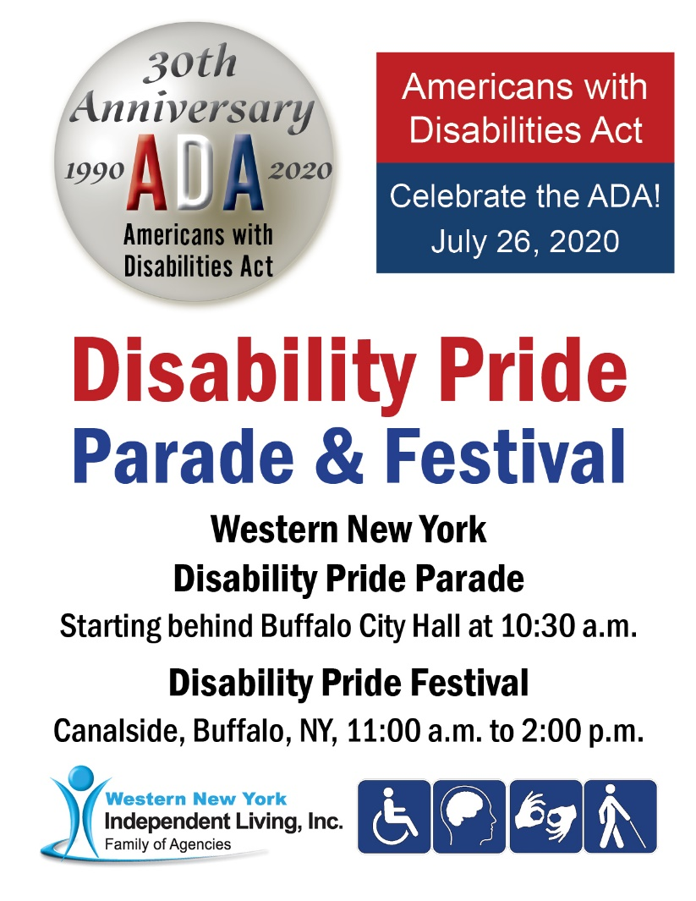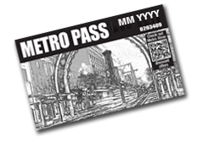

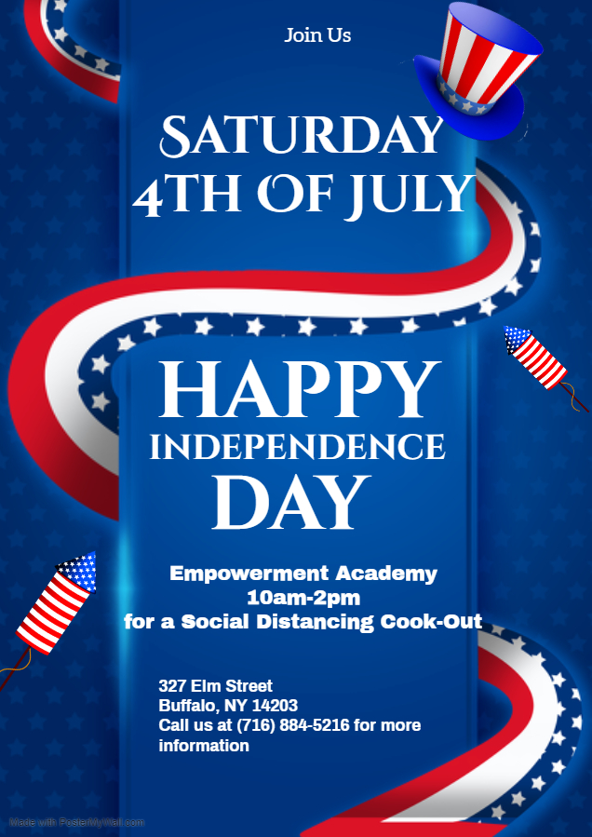

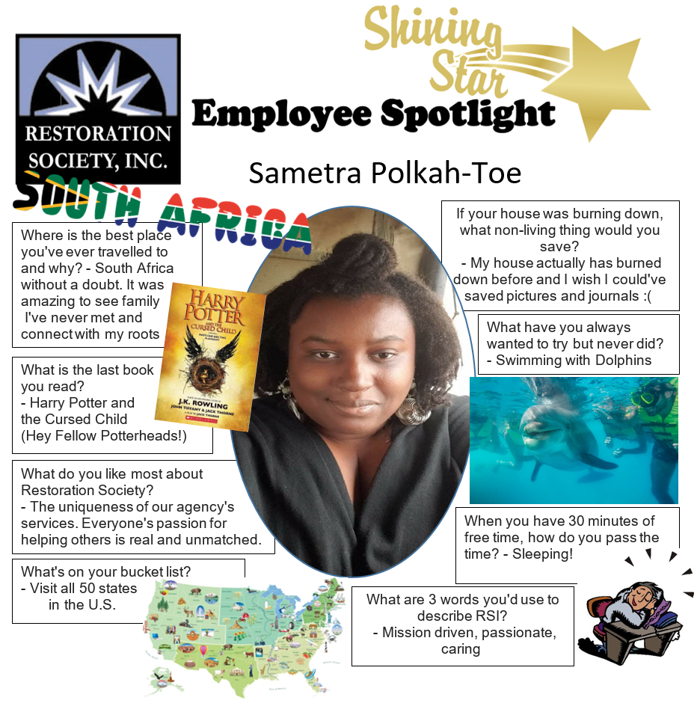

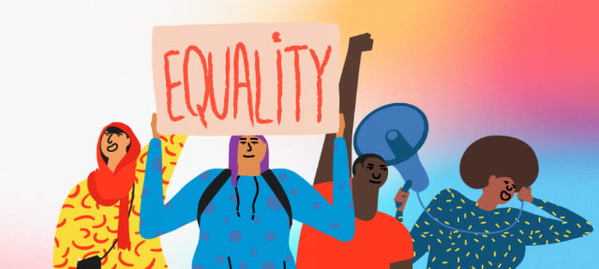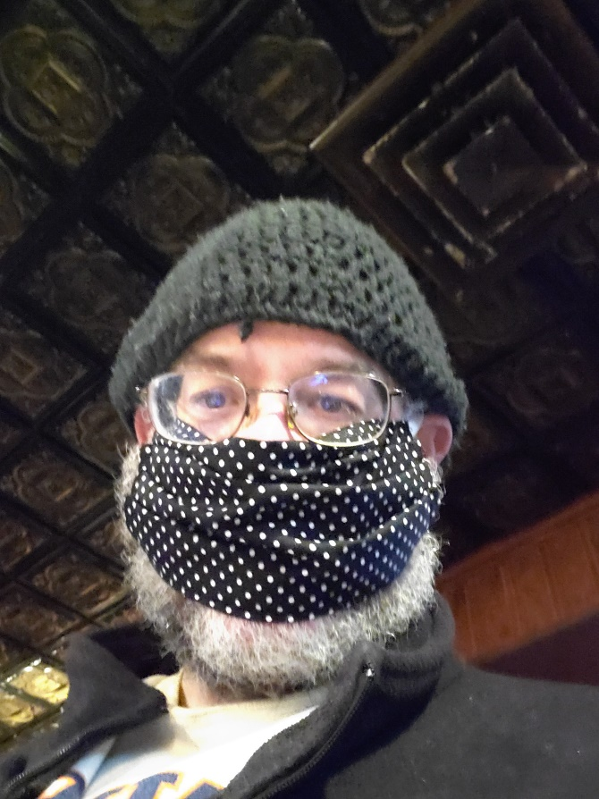A

**Equality is a must – RSI loves you all !**

 As most are aware, protests have erupted across the nation

(and internationally!) in a movement for black equality and an end to

police brutality. Naturally, there are varying opinions and levels of

interest in this issue. We here at RSI work with a wide array of people.

We do not discriminate no matter your race, sexual status, gender,

religion, or anything else. We love you all !

At a time like this, it is important to be open to discussion and learning. To us, it seems clear that all people deserve equal rights and respect. That is exactly what we here at RSI stand for.

Peaceful protest can be very effective. For any customers who choose to participate in protests (of their own volition – we are not suggesting you take part) – please do so safely and peacefully. We care about you and do not want anyone involved in acts of violence, no matter from which side it comes.

            Bottom line – Equality is a must !     ~Iris SB

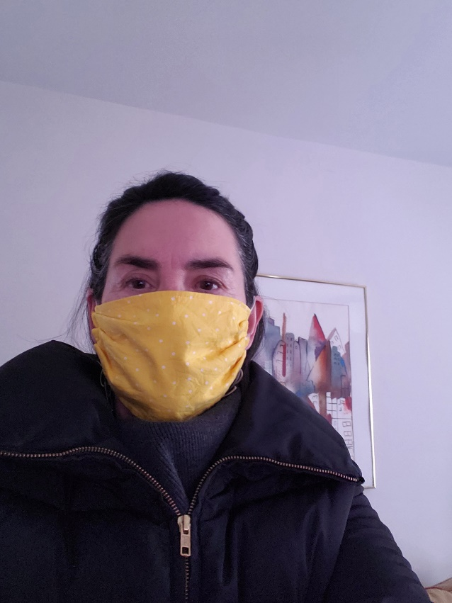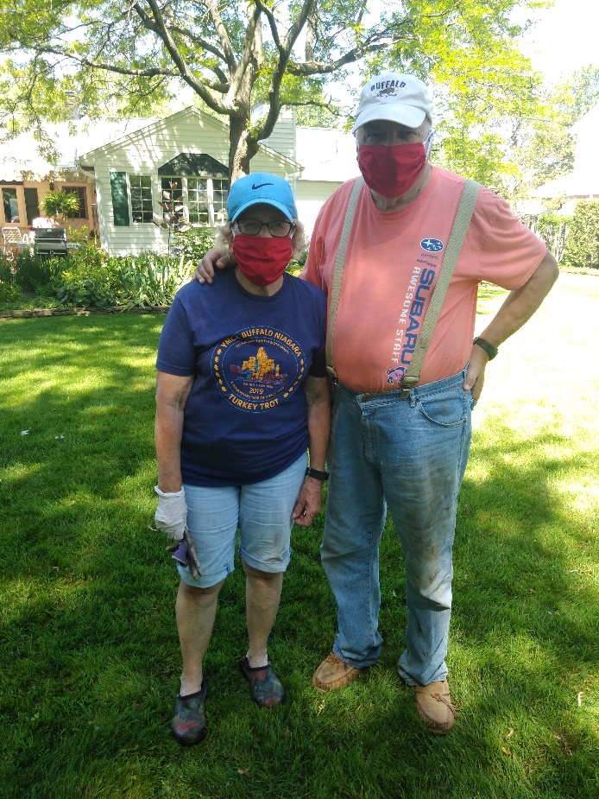****

Wear your mask like an Olympic sport (or like carrying a pool stick)!

There are two sides to a pancake. I savor those moments peri-pandemic with my service animal when I can choose my limits with the outer environment. Yes, to the freedom of the individual, no to hurting others. The simplicity of the wearing of one distills down to this because forgive me if I cannot consider the merits of the anti-wearing side (sweating, inconvenience, barrier to communication) to open my body up to being infected. I feel like wearing the mask and finding an alternative to blathering one’s opinion when there is a crisis isn’t the communication that’s needed.

Anyone who needs to communicate intimacy possibly (couples, roommates, families) would have to be in the know about the exposure to the corona in their lives (you would hope). Beyond that, it reminds me of bringing a service animal into the public and it can be the extroverts and ones who just have settled their mind on issues to speak from whom I ended up hearing. Could it be this movement to not wear masks that brings to light issues about people with disabilities in public, like the rhetoric is there.

Please find here 2 friend photos of masks that I made with the caveat that my friend from India did not want the mention! As Ken Jeong from “You Complete Me, Ho” said, now that is America (although it might have been more to do with living the American dream like huh?). I just cannot believe anyone could be angry about having to wear one, and also about bringing an animal into public. Misinformation during this era has infiltrated my brain and without knowing all the information, my anxiety worsens for when to speak and when to remain silent.

By Holly Martin 6-24-2020

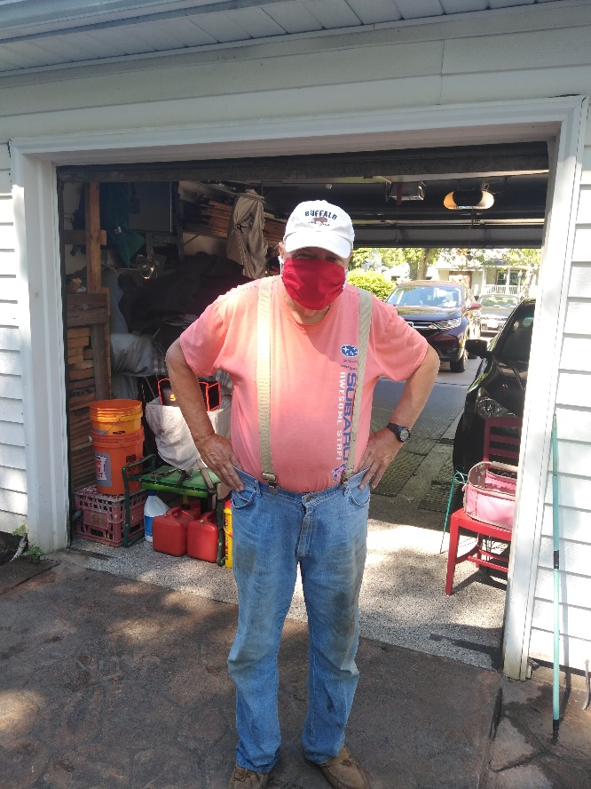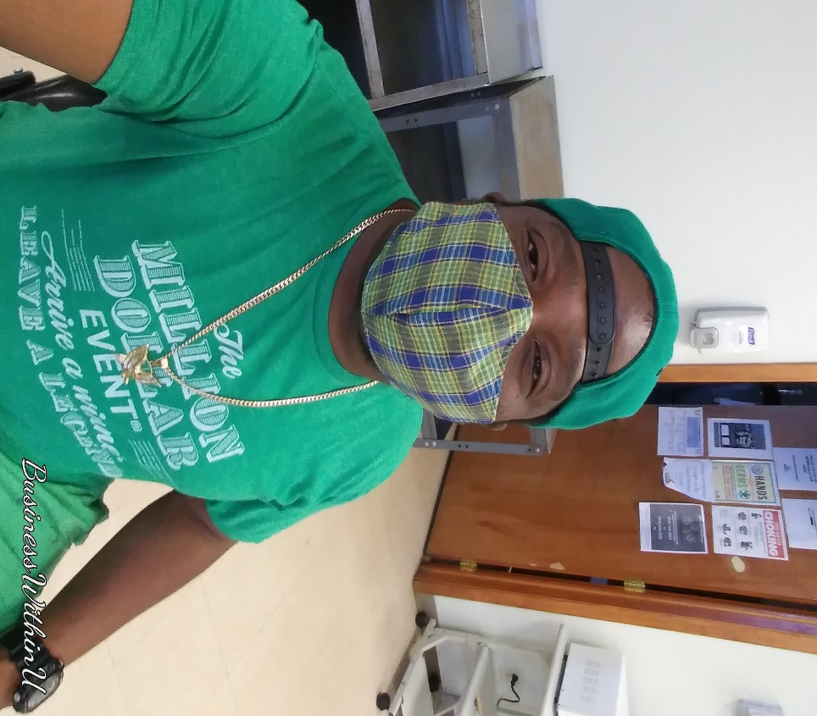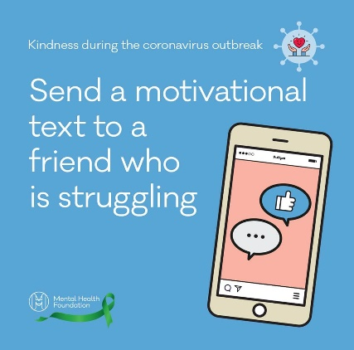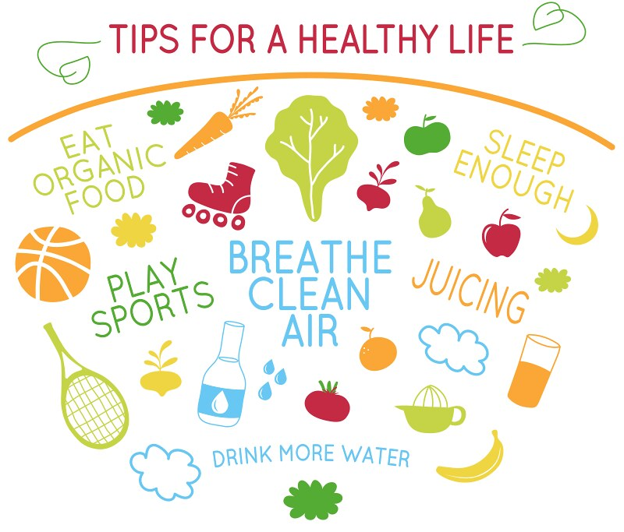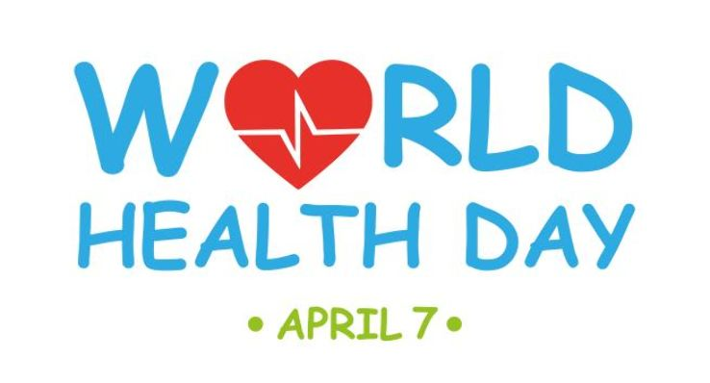

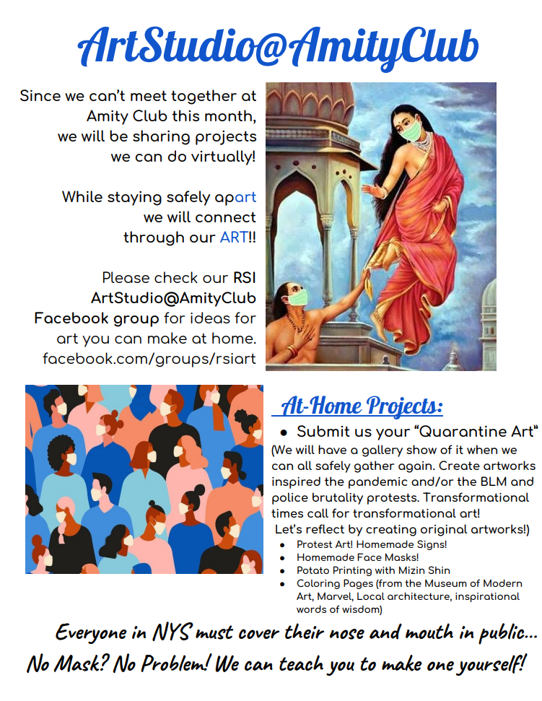

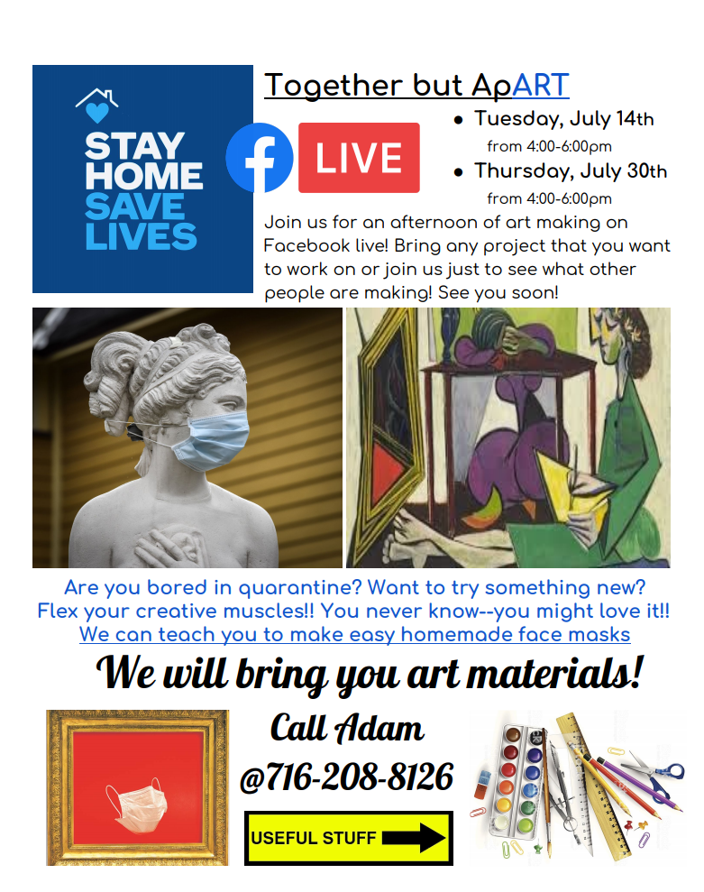

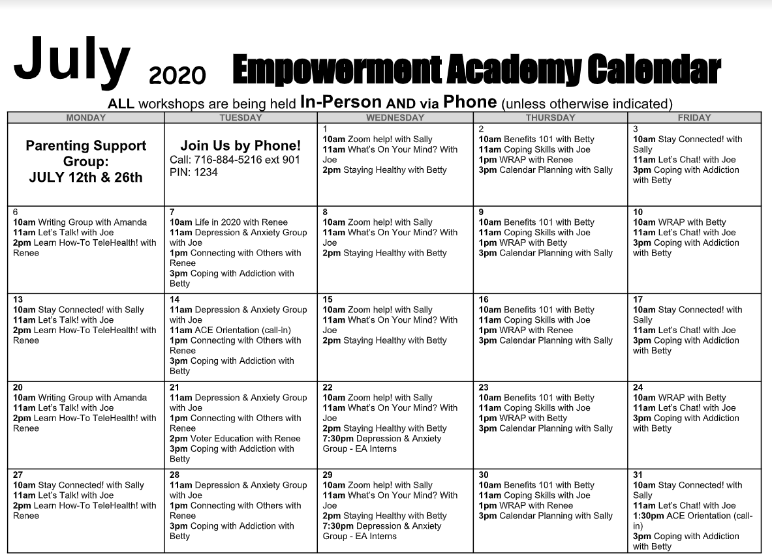

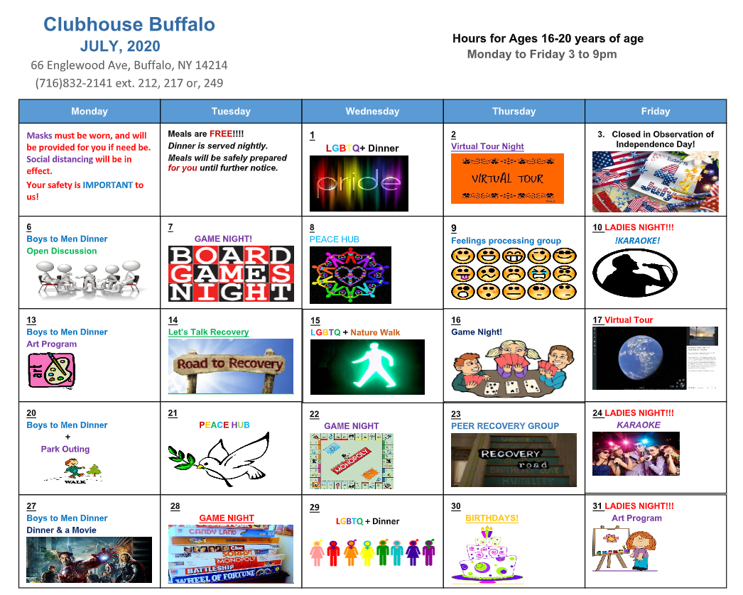

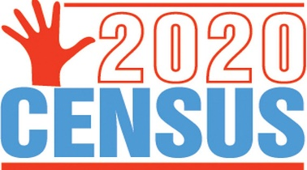

**Please complete the**

**2020 Census!!!**

**It’s not too late!!!!!!!!!!**

Did you know that the next 10 years of federal funding for non-profits like RSI are determined by Census data? The 2020 Census is for everyone--Even if you are currently experiencing homelessness--you need to be counted! Talk with your service provider (staff at your shelter, caseworker, or counselor) about getting counted today! [www.census.gov](http://www.census.gov/)

**OUR LOCATIONS:**

**66 Englewood Ave, Buffalo, NY 14214**

**(716) 832-2141**

**Administration Office, Housing Solutions & Clubhouse Buffalo**

**241 Genesee Street Buffalo, NY 14204**

**(716) 842-4184**

**Harbor House Resource Center & Coordinated Entry Hub**

**327 Elm Street, 2nd Floor Buffalo, NY 14203**

**(716) 884-5216**

**ACE Employment, Empowerment Academy, HCBS Services,**

**HARP Outreach Planning & Engagement, SOAR**

**220 East Main Street Batavia, NY 14020**

**(585) 343-9162**

**Genesee ACE Employment**

Restoration Society, Inc.

66 Englewood Avenue

Buffalo, NY 14214

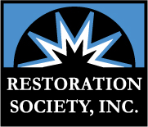



@RestorationSoc_1

***Visit us on the web at:***

[**www.rsiwny.org**](http://www.rsiwny.org)

**Facebook**

[**www.facebook.com/Restorationsocietyinc**](http://www.facebook.com/Restorationsocietyinc)