**4**

**Boys to Men Dinner**

**Arts and Crafts**



5

Peace Hub

**Homework Help**



6

**Meditation**



**8**

**Ladies Night**

**Virtual Walk through Alaska**



7

*Feelings Check In*



[First Super Bowl Played on 1/15/ 1967.](https://www.nfl.com/super-bowl/history/1967) Green Bay (35) defeated Kansas City (10).

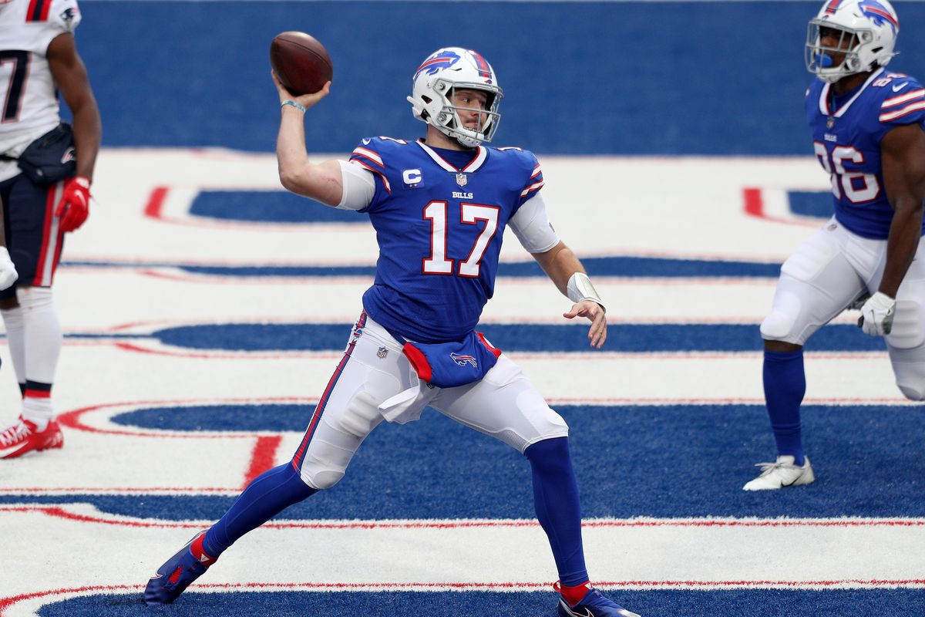

The Revolutionary War ended (1784)

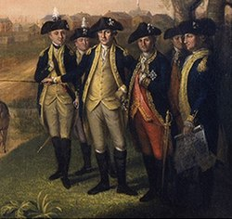

George Washington Carver was the most prominent black scientist of the early 20th century. He invented numerous products from sweet potatoes, including edible products like flour and vinegar and non-food items such as stains, dyes, paints and writing ink.

1 **Clubhouse CLOSED!!!!!!**



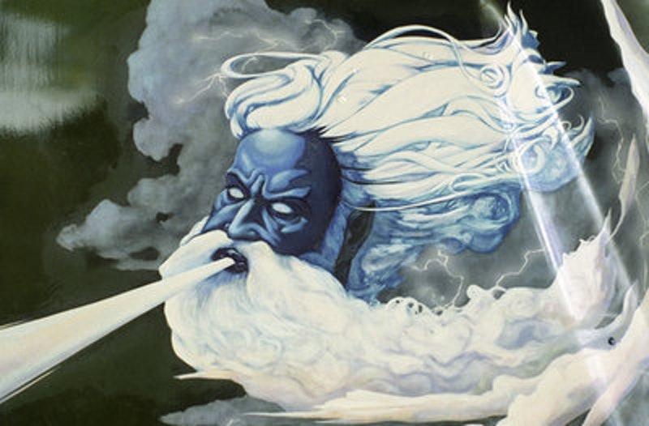

11 **Boys to Men Dinner**

**Recovery Support**



12 MOVIE NIGHT!@!!!!!

Check in day?

Emotional and Physical Boundaries

13

**LGBTQ+ Dinner**



15

**Ladies Night Fitness Day**

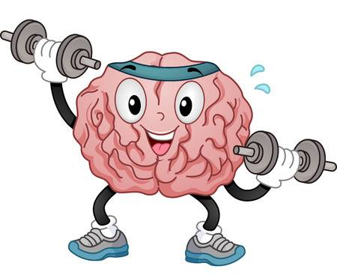

14

**Feelings Art Group**

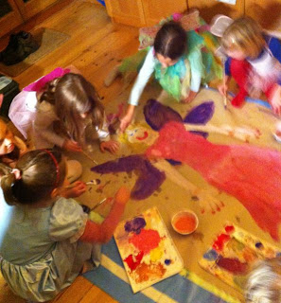

18

**Clubhouse Closed**

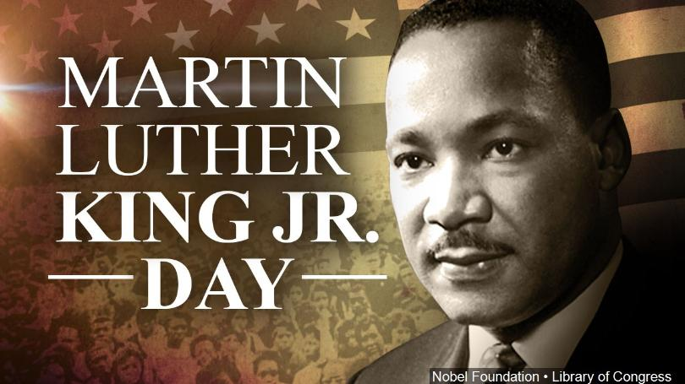

19 **Goals Check In Day**



20 [Inauguration Day](http://www.nea.org/tools/lessons/53997.htm)

**LGBTQ+ Dinner** 

**22 Ladies Night**

**Ted Talk**



21 **Poetry Night**



**25 Boys to Men Dinner** Fitness Dayss day

26 **Feelings Check**

27 **LGBTQ+ Dinner**

**Pool Tournament**



29 **JOB Application**

[National Puzzle Day](https://worksheets.theteacherscorner.net/)

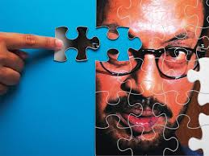

**28 Family Game Night (Charades)** **ght Sharades**

**Monday**

**Tuesday**

**Wednesday**

**Friday**

**Thursday**

Clubhouse Buffalo

January 2021

66 Englewood Ave, Buffalo, NY 14214

(716) 832-2141 ext. 212, 242 or, 249

**Hours for Ages 16-20 years of age**

**Monday to Friday 3 to 8pm**