**4**

4:30pm to 5:30pm

Boys to Men dinner

6pm to 7pm

ART PROGRAM-Drawing and painting

**5**

5:15pm to 6pm

Getting to know me

6:30 to 8:30pm

Game Night

**6**

4:30pm Peer Government Meeting

5:30pm to 6:30pm

LIFE SKILLS

8

5:30pm TO 6:30pm

Crochet night

LADIES NIGHT !!!!!!!!!!!!!!!!!

**7**

5pm to 5pm TED TALKS



**Meals are FREE!!!!**

Dinner is served at 5:30pm during the week. Please be here one hour before to sign up and participate in prepping

**Help with Homework**

3 to 4 pm is dedicated for help with homework for ages 16 and 17 year olds

## What’s Next

5 to 7pm on Wednesday’s are dedicated for personal development meetings with a coach. You can set up an appointment outside of these times if you need.

**1** **3pm to 7pm:** **Holiday Cards Contest with Empowerment Academy at the Clubhouse**

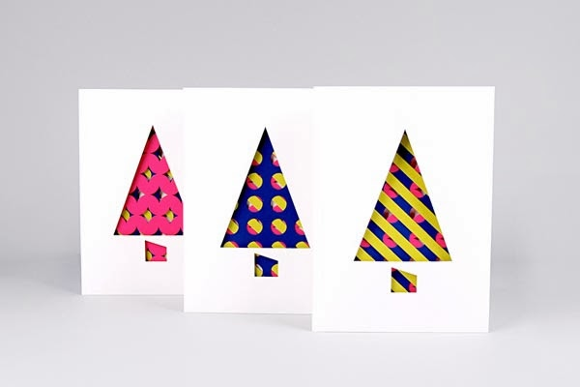



**11**

**CLOSED FOR VETERAN’S DAY**

**12**

5:30pm to 6:30pm

Earning and Giving RESPECT

**13**

6pm to 7:30pm

SIBLING NIGHT

**15**

6pm to 8pm Reiki with Ashley

5:30pm to 6:30pm Crochet night

LADIES NIGHT !!!!!!!!!!!!!!!!!

**14**

4pm Educational Pledge guest speaker

5:30pm to 6:30pm

Discussing Boundaries

**18**

4pm to Boys to Men dinner group Sandwich day

5:30pm to 7:30pm

BASKETBALL

**19**

5:30pm to 6:30pm

**EXPLORING HEALTHY RELATIONSHIPS**

**20**

4:30pm Peer Government Meeting

5:30p, to 7:30pm **SOY: Spotlight On Youth**

**22**

5:30pm TO 6:30pm

Crochet night

LADIES NIGHT !!!!!!!!!!!!!!!!!

**21**

**Thanksgiving Dinner**

**25**

4:30pm to 5:30pm

Boys to Men Dinner

6pm to 7pm Life skills

How to write a RESUME

**26 Monthly Birthday Celebration**



**27**

5pm to 6pm Guided Meditation

**29**

5:30pm TO 6:30pm

Crochet night

LADIES NIGHT !!!!!!!!!!!!!!!!!

28

**THANKSGIVING DAY CLUBHOUSE IS CLOSED**

**Monday**

**Tuesday**

**Wednesday**

**Friday**

**Thursday**

Clubhouse Buffalo

November, 2019

66 Englewood Ave, Buffalo, NY 14214

(716)832-2141 ext. 212, 217 or, 249

**Hours for Ages 16-23 years of age**

**Monday to Friday 3 to 9pm**