Recovery Happens

Illuminating pathways toward opportunity, possibility, wellness and independence.

###### Restoration Society, Inc., 66 Englewood Avenue, Buffalo, NY 14214

###### [www.rsiwny.org](http://www.rsiwny.org) (716) 832-2141 Fax (716) 832-0021

­––

Recovery Happens

Illuminating pathways toward opportunity, possibility, wellness and independence.

###### Restoration Society, Inc., 66 Englewood Avenue, Buffalo, NY 14214

###### [www.rsiwny.org](http://www.rsiwny.org) (716) 832-2141 Fax (716) 832-0021

April 2020

Volume 12, Issue 4

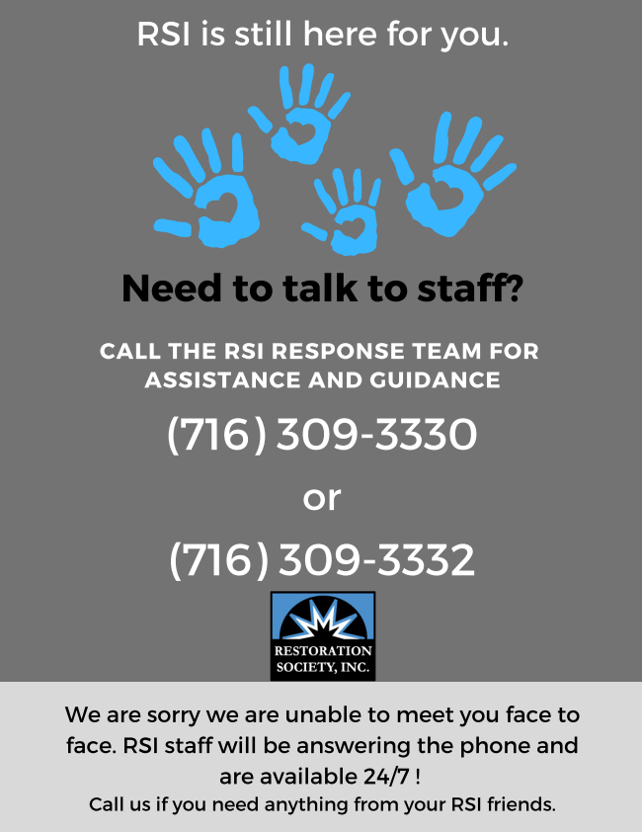

ALL NFTA BUS AND METRO RAIL FARES ARE **FREE!!!**



Peer Study Group Q/A Session

There will be a Q/A session live from the [RSI Staff](https://www.facebook.com/rsistaff1?__tn__=%2CdK-R-R&eid=ARDwdjGuXLV8AT8d1qate4bH1p1Z9Sh_3hh6h7IlV2ItJjImXN8LjlxgCGRDXmbEg_anQu98szCx3Q3f&fref=mentions) page on Facebook for the Peer Study Group attendees that's held every Wednesday. Cornelius Delaney of RSI's HOPE TEAM will be the facilitator, and will be able to answer any questions ask about Academy of Peers services. The live feed will begin at 2:00 p.m. and end promptly at 3:30 p.m. The end date for APS has been extended to 4/6/20. If there are any questions regarding this session, please do not hesitate to contact us by either direct message on Facebook or call at (716) 431-HOPE(4673).

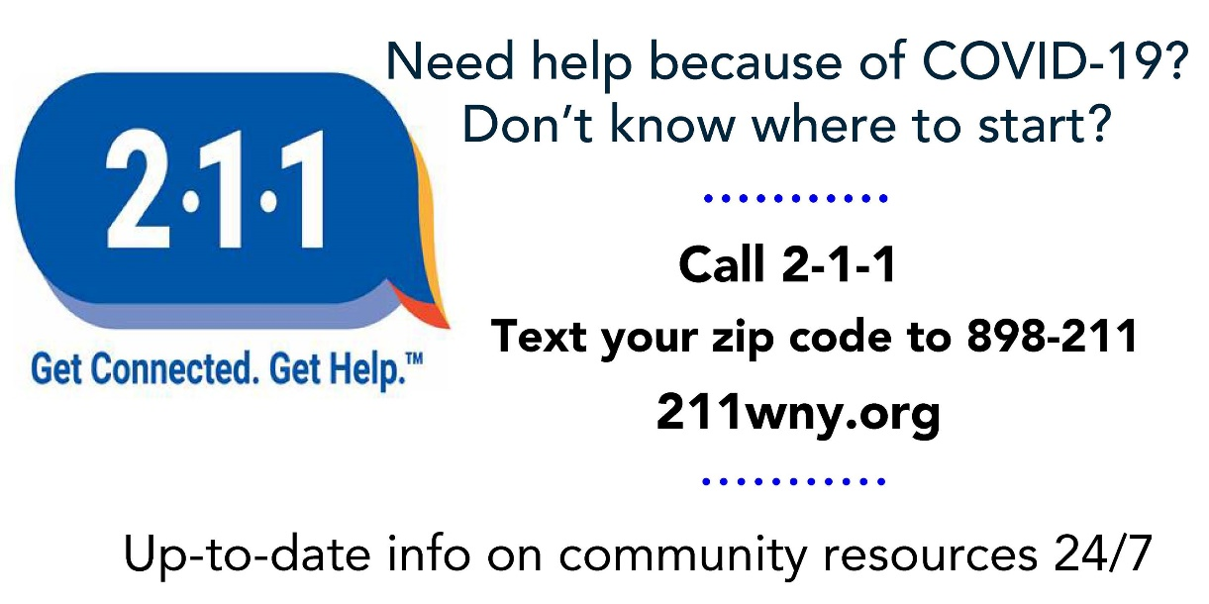

**Get to know ACE during our Informational sessions via phone calls!!!**

During the month of April Erie ACE will be taking phone calls, instead of having walk in open meetings, regarding our

**ACE Informational Sessions**

**April 7, 2020 - 10am-12pm and**

**April 24, 2020 12pm-2pm**

These calls will answer all your needs regarding our services, how we can help you choose, get and keep a job, and how to apply for Adult Career & Continuing Educational Services (ACCES-VR) services. Please call (716) 884-5216 ext: 410. Please leave a message and someone will be call you back within the time frame.

All stay well and safe!!!



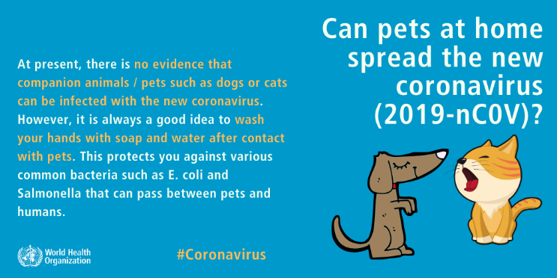

World Book day is on April 23rd 2020. Here are some reasons why we should read:

**1. Reading is good for your brain**

**2. Reading introduces you to new ideas and invites you to solve problems**

**3. Reading makes you a better writer**

**4. Reading improves your conversational skills**

**5. Reading strengthens worldview and convictions**

**6. Reading improves your self-discipline and consistency**

**7. Reading increases your knowledge of history**

**8. Reading increases cultural knowledge (without an expensive plane flight)**

**9. Reading challenges your imagination**

**10. Reading reduces stress**

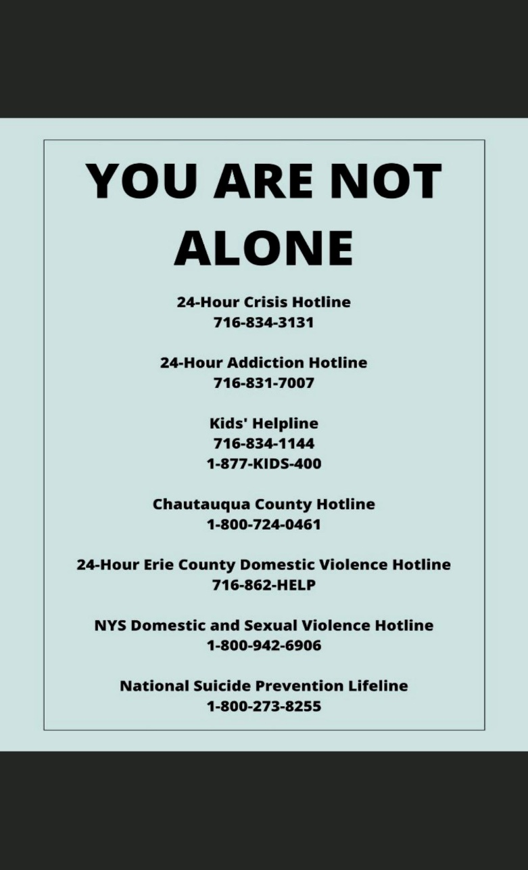

Harbor House!!

National Chains with Free Wifi

Starbucks

McDonald’s

Panera Bread

Dunkin Donuts

Tim Horton’s

SPoT Coffee

Buffalo Wild Wings

Apple Store

Marriot Hotels

Whole Foods

Staples and Office Depot

Target

Barnes & Noble

Best Buy

Other Local Options

Buffalo Public Library

Airport

Train Line (downtown only, above ground) via “Buffalo Connect”

Hospitals

Museums

This year, Easter will be observed on

 Sunday, April 12. (Eastern Orthodox

Easter will take place the following

Sunday, April 19.) Easter’s date is just

five days after [April’s full Moon](https://www.almanac.com/content/full-moon-april)

 (Tuesday, April 7), which is the first full

Moon to occur after the [spring equinox](https://www.almanac.com/content/first-day-spring-vernal-equinox)

and is therefore known in the Christian

calendar as the “[Paschal Full Moon](https://www.almanac.com/news/everything-almanac-news/easter-motions-moon).”

Easter Day, which falls on Sunday for most Christians in the U.S., celebrates the resurrection of Jesus Christ. After being executed on a cross on Good Friday, Jesus was buried in a tomb. That first Easter, some 2,000 years ago, God the Father raised Jesus from the dead.

Additional customs that have become associated with Easter and are observed by both Christians and some non-Christians include [egg hunting](https://en.wikipedia.org/wiki/Egg_hunting), the [Easter Bunny](https://en.wikipedia.org/wiki/Easter_Bunny), and [Easter parades](https://en.wikipedia.org/wiki/Easter_parade). There are also various traditional [Easter foods](https://en.wikipedia.org/wiki/Easter_food) that vary regionally.



@RestorationSoc_1

**Coronavirus Disease 2019 (COVID-19)**

**Resources & Support for those affected by COVID-19**

**Health Insurance**

* **Special Enrollment Period available to New Yorkers:** eligible individuals will be able to enroll in insurance coverage through NY State of Health, New York’s official health plan Marketplace, and directly through insurers. The open enrollment period for coverage in 2020 had previously ended on February 7, 2020. Individuals who enroll in Qualified Health Plans through NY State of Health or directly through insurers between March 16 and April 15, 2020 will have coverage effective starting April 1, 2020.  Individuals who are eligible for other NY State of Health programs – Medicaid, Essential Plan and Child Health Plus – can enroll year-round.  As always, consumers can apply for coverage through NY State of Health on-line at [nystateofhealth.ny.gov](https://nystateofhealth.ny.gov/), by phone at 855-355-5777, and working with [enrollment assistors](https://nystateofhealth.ny.gov/agent/hx_brokerSearch?fromPage=INDIVIDUAL&lang=en).

**Housing**

* Effective Monday March 16, all **eviction court proceedings**and pending eviction orders shall be**suspended statewide** until further notice. [(source)](http://www.nycourts.gov/whatsnew/pdf/Updated-Protocol-AttachmentA3.pdf)

**Legal**

* Effective 5pm on 3/16 New York State courts are closed for all non-essential functions until further notice. The Court System has an emergency number available 24/7 for questions from the public relating to court operations during this public health emergency: 800-268-7869
* Center for Elder Law & Justice will be taking COVID-19 related legal questions from seniors on its free legal helpline Monday-Friday, 9am-11am at 844-481-0973

**Social Security**

* Effective 3/17, Social Security Offices will be closed. **Phone service and online services remain available**. If you need help from Social Security visit [www.socialsecurity.gov](https://www.ssa.gov/onlineservices/) or call the national number 800-772-1213 which includes many automated services in addition to the option to speak to a representative.

**Utilities**

* New York State Department of Public Service announced that it would immediately work with utilities across the State to ensure any customers affected by COVID-19 restrictions they will not lose power or heat due to financial hardship.
* The State’s major electric and gas utilities — National Grid, New York State Electric and Gas, Rochester Electric and Gas, and National Fuel Gas — and major private water companies have all committed to suspend shut-offs for customers, and assist customers impacted by COVID-19 who may be experiencing financial hardship that makes it difficult for them to pay their utility bills during the outbreak.
* **Effective 3/16 the Department of Social Services stopped all non-emergency client appointments, in person help is still available for emergency needs: homelessness, eviction, and disconnected utilites. Applications for SNAP & HEAP assistance can be submitted electronically at** [**www.mybenefits.ny.gov**](http://www.mybenefits.ny.gov/) **Applications for certification or recertification can be dropped off at DSS or mailed to: Erie County Department of Social Services, PO Box 120, Buffalo NY 14201-9903 Please include a working telephone number for interview purposes. During this time, no negative actions will be taken as a result of cancelled or missed appointments. Clients will eventually be contacted to complete interviews by telephone or reschedule once it is deemed safe to conduct in-person certifications and recertification.**
* **The in-person interview requirement is waived for Temporary Assistance through April 11 for certifications and is waived through May 15 for recertification  
  ·     The requirement that clients come in person to have a photograph taken for their benefit card is waived through April 11  
  ·     Fair hearings will be conducted via telephone conference**

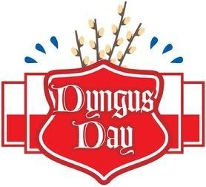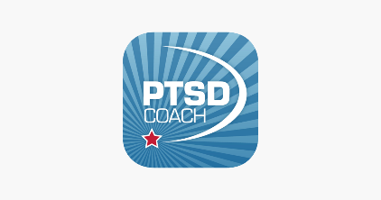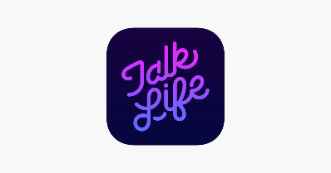****

To do you guys a “solid” during this time of social distancing,

there is a deep connection to others that I feel and I wanted

to provide a list of both free and not free Counseling apps.

1.       Talk Life (free) 5.       PTSD Coach (free)

2.       Woebot (free) 6.       Talkspace (paid subscription)

3.       BetterHelp ($65/week charged monthly) 7.       Imood journal (initial app fee)

4.       Thinkladder (free) 8.       Facebook might have a Recovery International

webpage and they offer online meetings

Each one has its own purpose and I did not have to go any further on Talkspace to understand that it could be expensive due to one on one attention and the office. BetterHelp seemed reasonable, even if no sliding scale was mentioned nor any insurance mentioned, at least as far as I went. I just tried those as far as I could go to see more about the financial component, to be conscientious. Tal life is a free chat forum that is divided into many different categories, and others comment, give hugs and share. Woebot’s purpose is more to reframe how things are going, like a quick solution that is generated by a series of questions and answers. Thinkladder was the one I found that didn’t cost anything and seemed again to provide alterative thoughts for many issues. PTSD Coach’s purpose is to serve veterans and individuals living with the emotional disturbance of PTSD. Imood’s purpose is like a check-in a person can do and rate their moods from 1-10 as well as allow a commentary. I can review my moods during a certain period as it collects the data!

By Holly Martin 3-21-20

***Dyngus Day Facts: 10 Things To Know About Polish Holiday***

**1. Dyngus Day falls the day after Easter and celebrates the end of lent.**

**2. Traditional Polish foods like kielbasa, pierogis and cabbage dishes are served.**

**Even lamb-shaped butter makes an appearance on tables.**

**3. The major highlight of the holiday is when single men chase women and attempt to throw water on the. The attempt is to throw water on a young woman a man might be interested in pursuing. The practice of throwing water on a young woman is said to represent purification and fertility.**

**4. Like the tossing of water, young men would also lightly hit women on their legs with pussy willows to express their interest.**

**5. The traditions of Dyngus Day began with the baptism of Prince Mieszko I in 966 A.D. and the celebrations following the first Polish monarch being baptized into Christianity.**

**6. The Tuesday following the Easter Monday Dyngus celebrations, women could seek their own revenge by throwing plates and dishes at the men.**

**7. Dyngus Day celebrations within Polish communities in the U.S. date back to the 1870s.**

**8. Other popular celebratory activities include polka-dancing and drinking beer.**

**9. The Monday parties can last well into the evening and end in the daylight hours of Tuesday.**

**10. The word “Dyngus” can apparently be traced back to an old form of “Dingus,” which can mean “proper, suitable or worthy.”** **https://www.ibtimes.com/dyngus-day-facts-10-things-know-about-polish-holiday-2526288**

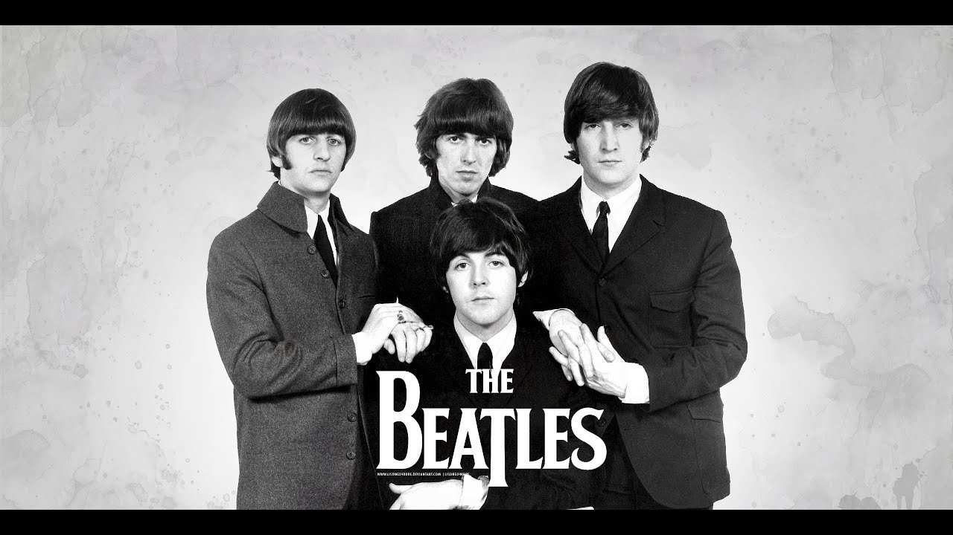

Why I love The Beatles.

by Tim Malley

I mentioned other groups that I love in the past such as The Byrds and The Moody Blues but today I would like to mention another group that I love and they of course are The Beatles I love the Beatles because I was always fascinated by the Beatles great songwriting team of Lennon and McCartney[even though John Lennon  was seen as the leader of the Beatles I believe the real force behind the Beatles was Paul McCartney because I believe Paul McCartney was also the real genius behind the Beatles who eventually outgrew the Beatles.]who seemed to churn out mega hits by the dozens that were also covered by other artists in the 1960s such as; here there and everywhere' which was covered by petula clark,michelle and yesterday which were covered by dozens of other artists in 1960s matt munro and the Count Basie orchestra among others.but I also liked the talents of George Harrison and ringo starr[who was born Richard Starkey and his first claim to fame was when he played the drums for Rory storm and The Hurricanes who was a band that played in Hamburg, Germany in 1960 when the Beatles played in Germany but at that point the Beatles were a backing band to the singer Tony Sheridan who had a relatively big hit in 1960 with the song my bonnie'.]its sad that even today that George Harrison is still considered the inferior to john and paul when in reality George Harrison also wrote excellent songs such as: here comes the sun, ‘while my guitar gently weeps, and something.'among others[in fact something was considered George Harrison’s masterpiece when he was with the Beatles in fact when the song was released in 1969 for inclusion on the Beatles brilliant album abbey road at that particular time when something was released Frank Sinatra said that George Harrisons song something, was one of the great love songs of the past 40 years and by the way Frank Sinatra did a great job in covering George Harrison’s song something'.]and ringo starr did a great job of laying down a steady beat but ringo starr also did a fantastic job of covering songs such as; the Carl Perkins penned honey dont' the Buck Owens penned act naturally' and of course his excellent cover the Lennon and McCartney penned song I wanna be your man.'[which was also covered by the rolling stones.]there are so many great albums by the Beatles but personal favorite is Rubber Soul' which was released in 1965 Rubber soul was just loaded with great songs such as;michelle'girl'and im looking through you'which were all penned by lennon and McCartney.the beatles I mean what can you say other than to be totally dazzled by their level of musical expertise that still defy musicologists to this day you  also cant defy great talent which is what the Beatles had compared other musical artists at that time[and there defining moment as a live act came also in 1965 with their shea stadium concert which was a tremendous success and displayed to the world that the Beatles were a real force when it came to talent.]they were the best of the best and that's why I love the Beatles.



World Health Day- Chris

Voting in the Age of Coronavirus

by Adam Selon

Every year we say this election is the most important election in our lifetimes and I dare say it is more true this year than ever! but voting in the April 28 presidential primary and 27th Congressional District special election this year has the potential to be one of the more difficult ever to “Get out the Vote” due to the need to have all citizens adopt physical distancing practices. Even though Erie County has the largest number of polling places in Western New York and the longest hours of any early voting site in New York your best bet to cast your vote amid the COVID-19 outbreak is to vote Absentee (Mail-in a vote)!

It is possible that Governor Cuomo could follow suit with the other states like Louisiana and delay the primary and special election to later in the spring like June when life might get back to normal...but that remains to be decided and announced. The best place to get updated info on voting in your area is on your local board of elections website at www.elections.erie.gov where you can register to vote, find your voting district and print absentee ballots or if you don't have a printer at home you may request a ballot be mailed to you!

The best way to ensure your vote is cast and counted is to participate in early absentee voting by completing an Absentee Ballot (Anyone can now qualify for absentee voting due to the COVID-19 threat) Absentee ballots can be mailed to

“Erie County Board of Elections 134 West Eagle Street Buffalo, New York 14202”

and (as of now) must be postmarked by April 21st.

Our community is no stranger to voting barriers so let’s not let the outbreak of COVID-19 stop us this year! We can still get out the vote in this pivotal election while staying in!

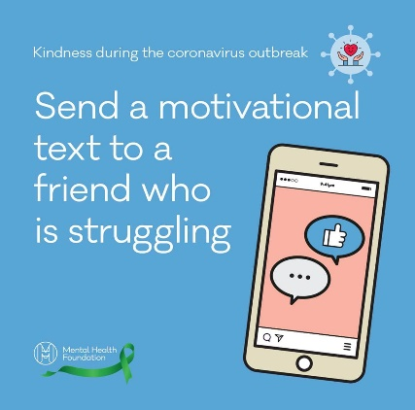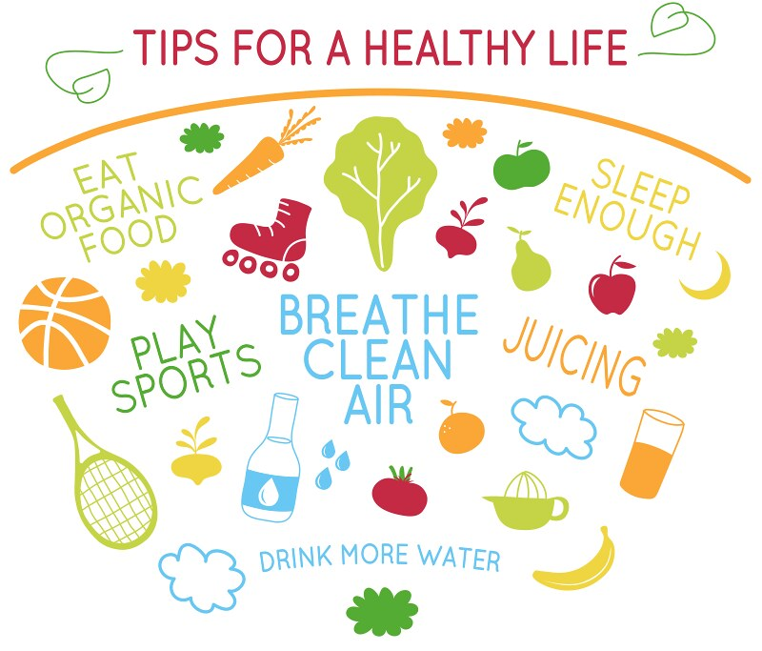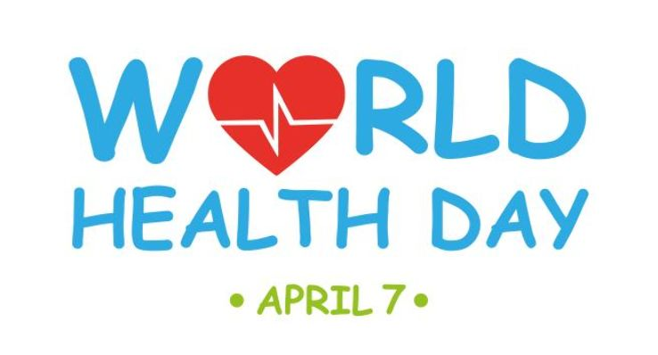



April is Stress Awareness Month!

Purpose is to increase public awareness about both the causes and cures for our modern stress epidemic.

Quick ways to destress:

* Change the environment and do something pleasurable or relaxing for a little while such as reading, watching TV/Youtube
* Practice breathing exercises
* Meditate or pray
* Do relaxation exercises
* Go walking or running
* Practice a rhythmic activity
* Immerse yourself in a creative outlet.



Many Food Pantries Are Open!!

(Try to call first as things may change)

Closest to Harbor House:

**Urban Christian Ministries**

967 Jefferson Ave Buffalo

716-882-9472

14204, 14208, 14211

Tuesday & Friday 11-1, 2-5:30

Thursday 11-1

**TJ Dulski Pantry**

129 Lewis St Buffalo

716-893-7222 x401

14206

Wednesday 10:30-2:30

**Family Help Center**

60 Dingens St Buffalo

716-892-2172

14206

Tuesday & Thursday 9-1

**Catholic Charities Lovejoy**

139 Ogden St Buffalo

716-312-7510

14206

Wednesday & Friday 9:30-2:30

(closed 12-12:30 for lunch)

**Response to Love**

130 Koscuszki St Buffalo

716-894-7030 option 7

Open to All

Monday-Thursday 9-11:15

**Buffalo Lutheran Pantry**

900 Genesee St Buffalo

716-892-7682

14211

Monday-Thursday 9:30-11

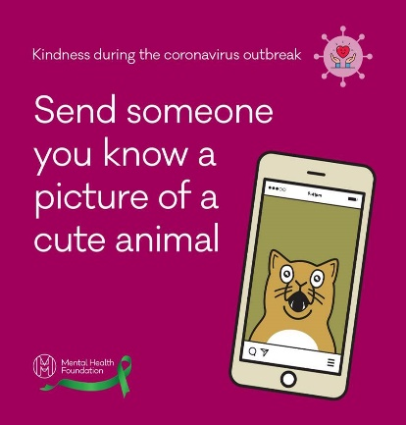



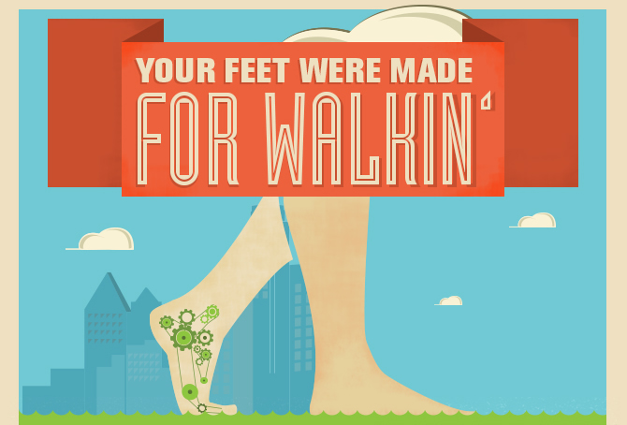

***April 1st is National Walking Day***

Dyngus Day/Easter Cooking- easy recipe for customers-Bertia

**Get out there and WALK**

Right now, we can all agree the world is chaotic, confusing, isolating.

We are wondering what we can possibly do to pass time and stay busy with so many businesses closed. You know one thing we call all enjoy? A little fresh air! For those of us who can, even a 30-minute walk can help get your blood flowing, stretch your muscles, and stimulate your brain. Plus – it's an excuse to get outside! Buffalo has so many places to offer within the city itself. Enjoy our Olmstead Park System, which many other cities don't have! This is the time to appreciate the little things. So take a deep breath of fresh air and enjoy a nice walk – and not just for one day! ~ Iris S-B

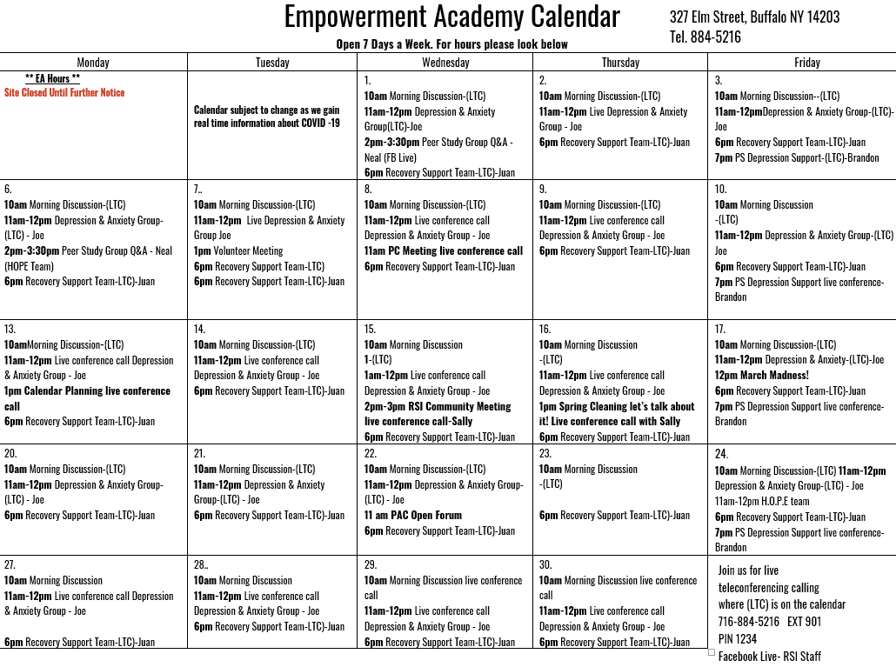

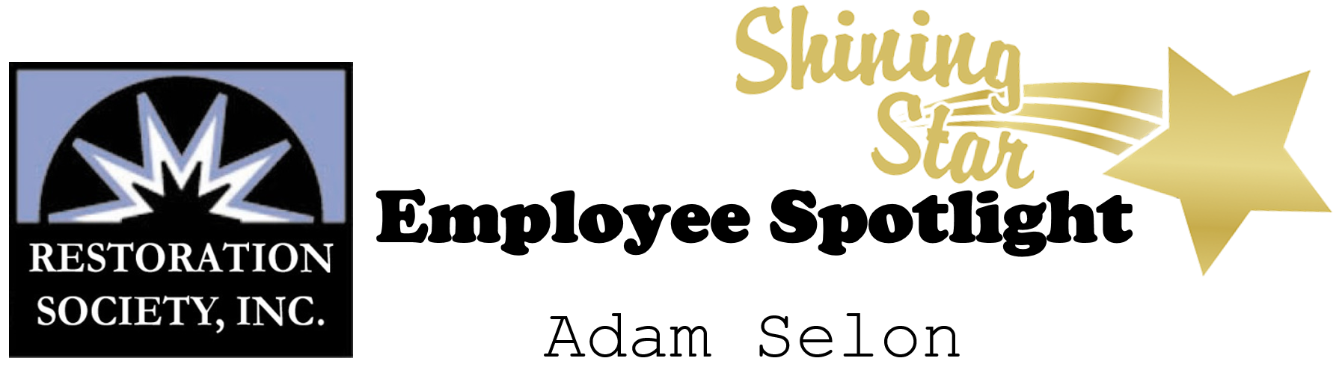

When you have 30 minutes of free-time, how do you pass the time?

Read the news to catch up on current events in the world.

If you were stuck on an island what three things would you bring?

Phone, Food, and a Blanket.

What is on your bucket list?

Travel through Europe

What’s your favorite indoor/outdoor activity?

Basketball

Where is your favorite place to be? Definitely would be

St. Pete, Florida

If you won the lottery, what is the first thing you would do?

Go to Disney, of course!!!

Shannon Petersen

What is your greatest fear?

I absolutely despise spiders!

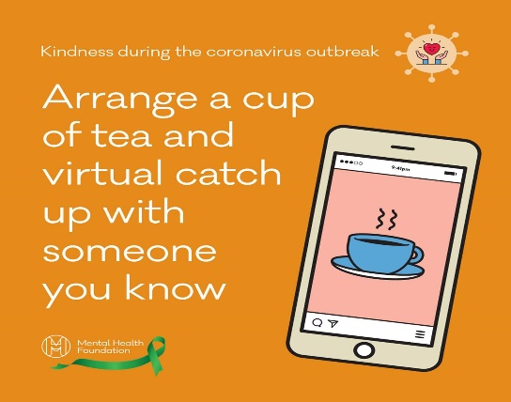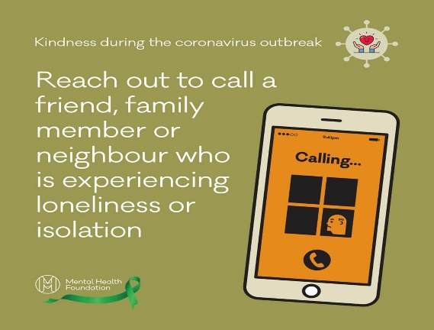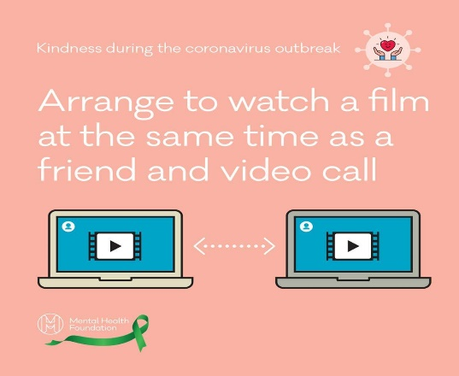

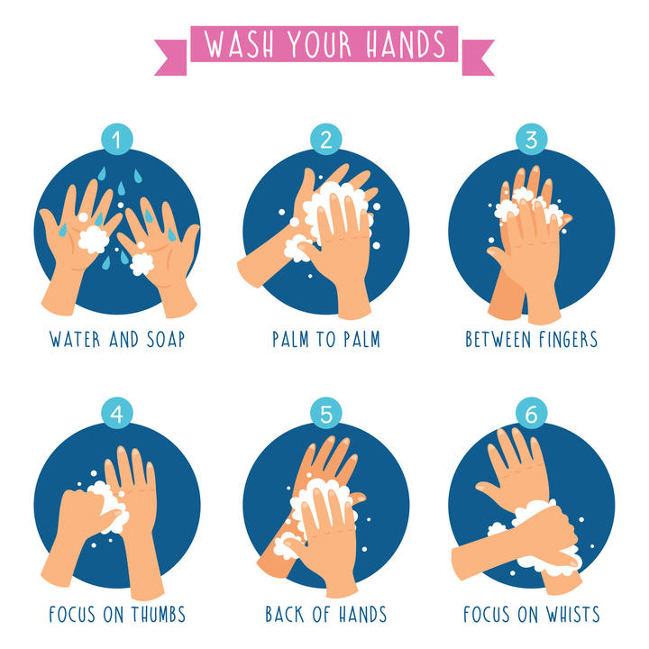

**OUR LOCATIONS:**

**66 Englewood Ave, Buffalo, NY 14214**

**(716) 832-2141**

**Administration Office, Housing Solutions & Clubhouse Buffalo**

**241 Genesee Street Buffalo, NY 14204**

**(716) 842-4184**

**Harbor House Resource Center & Coordinated Entry Hub**

**327 Elm Street, 2nd Floor Buffalo, NY 14203**

**(716) 884-5216**

**ACE Employment, Empowerment Academy, HCBS Services,**

**HARP Outreach Planning & Engagement, SOAR**

**220 East Main Street Batavia, NY 14020**

**(585) 343-9162**

**Genesee ACE Employment**

Restoration Society, Inc.

66 Englewood Avenue

Buffalo, NY 14214

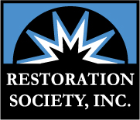



***Visit us on the web at:***

[**www.rsiwny.org**](http://www.rsiwny.org)

**Facebook**

[**www.facebook.com/Restorationsocietyinc**](http://www.facebook.com/Restorationsocietyinc)