**5** Boys to Men dinner

ART PROGRAM-Drawing and painting



6 Peace Hub-Game Night



**7 LGBTQA+ Dinner**

**Fitness Day**



9 **LADIES NIGHT!!!!!!!!!!!!!!!!!**

**Ice Cream**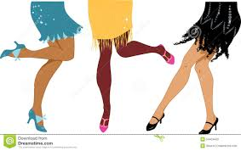am Day

8 TED TALK

Ice Cream Sunday

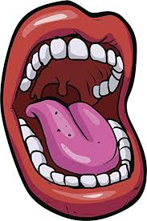

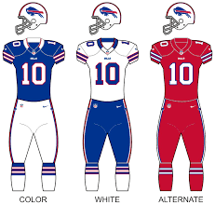



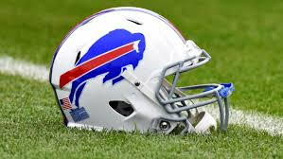

**2** LADIES NIGHT !!!!!!!!!!!!!!!!!

Dance Party Social



1

**Virtual Tour-Gamer Night**

12 **NATIVE PEOPLES DAY**

**Boys to Men dinner**

**LIFE SKILLS-etiquette**

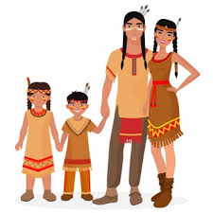

**13 TED TALKS**

**Movie Night**



**14 *LGBTQA+*** **Dinner**

**Nature Walk**



**16 LADIES NIGHT**

**Popcorn and a Movie**

**National BOSSES DAY**



**15 *Candy marking Day***

**Cartoon Art**

19 Boys to Men dinner

Personal Fitness



**20 Recovery Support**

**Karaoke**



**21 LGBTQA+ Dinner**

**Water Color ART**

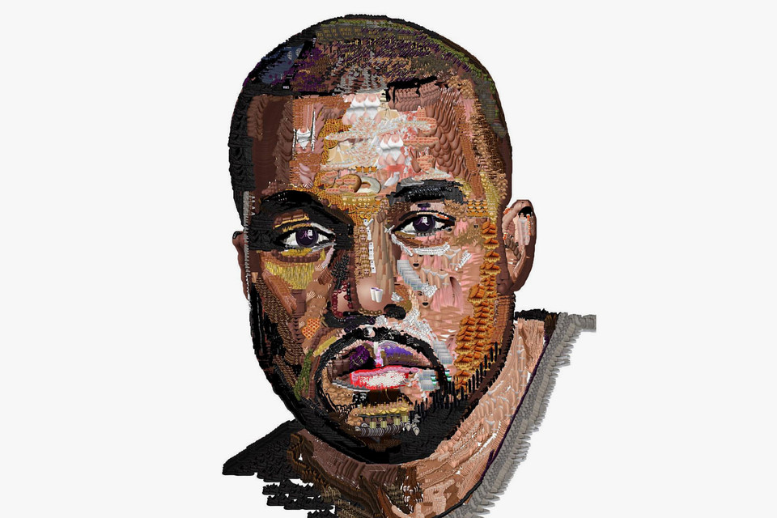

**23**

**LADIES NIGHT !!!!!!!!!!!!!!!!!**

**Getting to know ME!!**



**22 Peace HUB**

**Dinner and a MOVIE!!!**



26 **Boys to Men Dinner**

**Exploring Healthy Relationships****onships**

27 ***Virtual Tour***

***Homework Help***



**28 LGBTQA+ Dinner**

**Peer Recovery Group**



30 **Halloween Party**

**Bring a Family Member**

**Birthday Celebrations**

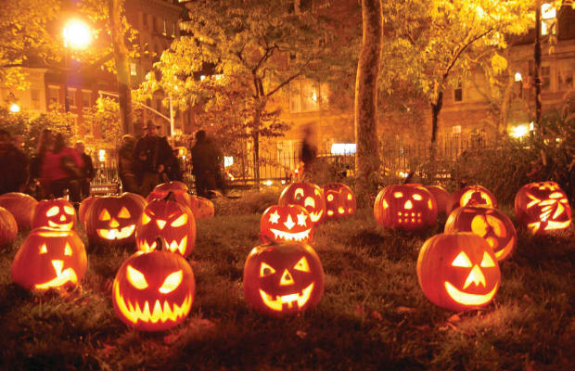

29 **Pool Tournament**

**Karaoke**

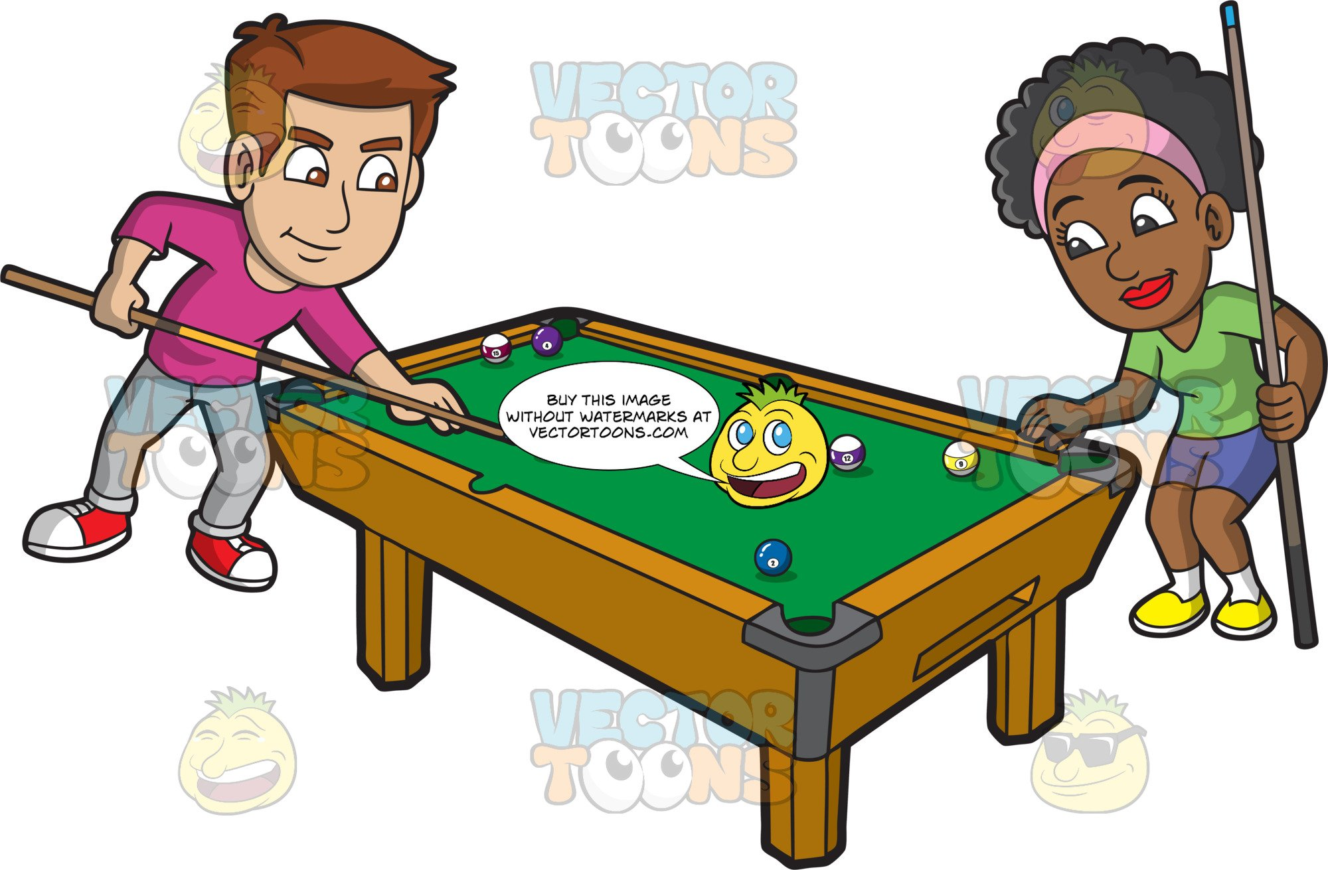

**Monday**

**Tuesday**

**Wednesday**

**Friday**

**Thursday**

Clubhouse Buffalo

October, 2020

66 Englewood Ave, Buffalo, NY 14214

(716)832-2141 ext. 212, 217 or, 249

**Hours for Ages 16-20 years of age**

**Monday to Friday 3 to 9pm**