**Happiness**

**Is a Habit**

**Cultivate It.**

Restoration Society, Inc. programs are rehabilitation communities founded upon the recovery vision that all individuals can lead active lives filled with hope and satisfaction and make valuable contributions to our community.

A recovery, wellness and life achievement focus promotes and supports the development of new meaning and purpose in one’s life as one grows beyond the challenges.

Values

The values came from the dynamic collaborative partnership among customers, staff, administration and the Board of Directors, all of whom comprise the agency.

- Respectful -  Holistic –Ethical- Optimism- Supportive- Peer Advocacy- Team Work -  Empowerment- Opportunity- Resiliency-

Integrity- Nurturing-Growth

Help to form our foundation which drives all Restoration Society, Inc. endeavors.

Mission Statement

Illuminating pathways toward opportunity, possibility, wellness and independence.

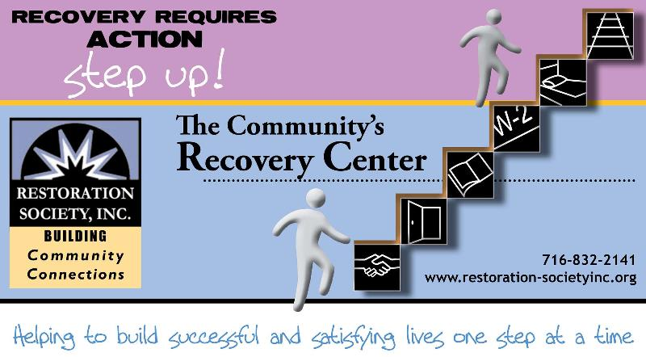

###### Restoration Society, Inc., 66 Englewood Avenue, Buffalo, NY 14214

###### [www.restoration-societyinc.org](http://www.restoration-societyinc.org) (716) 832-2141 Fax (716) 832-0021

Recovery Happens

April 2017

Volume 9, Issue 4

**ACE Employment Services**

**Informational Session**

April 10, 2017 at 1:30 pm

April 28, 2017 at 10:00pm

327 Elm Street Corner

of Elm and Genesee

Having a Disability Does

Not Mean You can’t Work

Introduction To The Three Different Employment Services ACE Provides

Please Contact:

Fran Gullo (716)884-5216 Ext. 407

**YOUNG ADULT RECOVERYCLUBHOUSE**

**IS NOW OPEN**

66 Englewood Ave

Buffalo, NY 14214

A welcoming peer run community space providing positive alternatives for young adults 18-21 who have or at risk of a substance use disorder.

Hours are Monday-Friday 5pm-9pm

Saturday-Sunday 10am-8pm

Questions please call

Robert at (716)832-2141 ext. 217

**Restoration Society, Inc**

**is able to provide**

**Home and Community**

**Based Services**

These are the services we are currently offering Erie, Genesee, Niagara, Monroe and Orleans County:

* Psychosocial Rehabilitation
* Habilitation
* Family Support and Training
* Education Support Services
* Empowerment Services- Peer Supports
* Pre-vocational Services
* Transitional Employment
* Intensive Supported Employment (ISE)
* Ongoing Supported Employment

Please contact these staff people for more information on Home and Community Based Services at Restoration Society, Inc.

Genesee, Orleans and Monroe County – Heather Kemp, [585-343-9162, ext. 301](tel:585-343-9162%2C%20ext.%20301)

Erie and Niagara County – Stephanie Berent, [716-884-5216, ext. 401](tel:716-884-5216%2C%20ext.%20401)

Restoration Society, Inc. is a Certified Ticket to Work Employment Network

* Whether you are seeking full or part-time employment, we can help.
* Employment Services include advisement by certified benefits advisors and career consultations are FREE of charge!
* It only applies if you are on Social Security benefits!!!
* On or off site support, YOUR Choice

Please Contact:

Michelle Hovey (Erie County)

(716)884-5216 ext. 406

Gail McKee (Genesee County)

(585) 343-9162 ext. 307

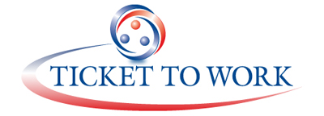

**There’s a Silver Lining in Every Situation**By, Tim

Positive thinking is such a wonderful tool to use for our own emotional well-being. Some people may not realize it but it seems as though our problems can overwhelm us and everything in our world looks so hopeless at times. For example, bills need to be paid and you worry that you won’t have enough money to go around to feed you and your family; you may also be experiencing grinding poverty and this could be one of the main reasons as to why you not only have trouble paying your bills and making ends meet but you may also be swimming in a sea of debt. You’re also probably worried about what your future holds for you. If I could give some advice: stay positive because there’s a silver lining in every situation. Positive thinking is not hocus pocus, it really works! Not only does positive thinking help people to think better but it also helps a person to control their anger and hostility. How many times during a situation regarding domestic abuse there is always an escalation of hostility and violence between couples; they start to become verbally abusive towards one another. They don’t know how to cope. I’m not saying that positive thinking is a cure all the time to all societies. A few things that I do know regarding positive thinking is when a person is struggling in life, it’s great to see someone stay so upbeat because it suggests that person refuses to let his or her problems bother them. It tells me that they’ve got dogged determination and are fighters and refuse to give up in life. Secondly the other thing that I know regarding positive thinking is that it hand in hand with self-control or being able to control one’s temper. So if positive thinking is only to be used to prevent domestic abuse from happening in the first place then in my view it has done its job. There’s nothing uglier and more destructive than domestic abuse and if more couples would learn to be more respectful towards each other than less abuse would happen. There is definitely a silver lining because not only does positive thinking radically change a person’s thinking but it can also radically change the environment in which a person lives. Instead of being subjected to constant strife with utilizing positive thinking a couple will be subjected to a peaceful and respectful environment safe from danger whatsoever. These are just some of the positive fruits of positive thinking and this should be positive news to anyone.

**First Day Member**By, Jamal

My feelings about the Restoration Society’s Empowerment Academy were unsure at first. I am at a very low point in my life due to my unstable financial circumstance. Being broke and homeless makes the average person lose hope and focus. But this program gives a person like me a positive setting where I can figure some things out to better my life. The staff there is very welcoming and friendly. There are a lot of people who go through similar hardships such as me. The program provides a free lunch for all members that attend, so that’s kind of cool. We interact with each other with group activities that improves social, coping, and problem solving skills. One of the most pleasant parts of the program is that they have these brilliant interns that are easy to talk to and very down to Earth. Overall, the program is cool, I hope I benefit from coming and I plan to come back.

**Spring Ahead, Spread your Wings, and Fly with Restoration Society**By, Brian

Now could be a time to change with a season of renewal and reinvention; possibly an opportunity to graduate from my day treatment. However, RSI will always be there for support. I have thirty plus years at RSI with a good background, I would like to expand my horizons.

**Living in the street**

By, Jevon

Living in the street walking every day and getting up from sitting at the Harbor House from 9:00pm until 11:00 in the morning but my baby girl keeps my mind at ease and keep on going day by day and I thank the Lord to keep me alive.

**Mental Health Awareness**

**Informational Fair &**

**5th Annual Flash Mob**

**May 4, 2017 10-1pm**

**At Buffalo Central Library**

**1 Lafayette Square**

**Buffalo, NY 14203**

**\*We are looking for agencies to set up tables at the event\***

**\*We are looking for volunteers to help with the event\***

**Please Contact Michelle S**

**At (716)832-2141 ext. 230**

**For more information**

**People**

By, Rashene

What I like about the Restoration Society is it helps people find work by doing chores, working in the kitchen and snack bar. What I also like is that we go on trips.

**A Great Place Testimonial**

By Gerry I am a long standing member of the Restoration Society from the Elmwood Clubhouse, which is now the Empowerment Academy. It’s a great place to recover your life and to work on personal goals. The staff is there for your rehab and to help you with personal issues in your life. They have daily activities, workshops, and go out different places that have historic value. The staff is there for you. The Empowerment Academy is open seven days a week, some days longer than others. Let’s hope in coming months Saturdays would have longer hours and Sundays too. They have computers, workout machines, tournaments, card playing, pool, trivia, and much more! They are located on Elm at Genesee Street and are always looking for new members. They do specialize in the mental health field and with what diagnosis you have so stop and see Amanda, Jay, Sametra, Dennis, Renee, Eric, and Reece. They are all qualified staff in certain fields of Psychology.

**Help our Fellow Less Fortunate**

**Community Members with Needed Resources**

**March 1-April 17, 2017**

**What is needed? New/Gently Used/ Clean**

**Furniture, Household Items, Clothing or**

**Personal Care Items**

**For more information or to arrange drop-off of needed items, contact : Melissa (716)444-4814 or email** [**melissafrawley222@msn.com**](mailto:melissafrawley222@msn.com)

**Donations will be distributed through local agencies & organizations,**

**including: Community Missions Inc., Restoration Society, Inc.,**

**and Matt Urban HOPE Center.**

**Administration Office, Housing Solutions**

**& Young Adult Clubhouse**

**66 Englewood Ave, Buffalo, NY 14214**

**(716)832-2141**

CFO-Sun-Ok King ext.213

COO-Kimberly Baughan ext. 215

Data Manager- Kimberly Muoio ext. 210

Housing Solutions Manager- Jean Bennett ext. 219

Recovery Center Service Coordinator

Michelle Scheib ext. 230

Young Adult Recovery Club Manager

Robert Morrow ext. 217

**Harbor House Resource Center**

**241 Genesee Street Buffalo, NY 14204**

**(716)842-4184**

**ACE Employment and Empowerment Academy**

**327 Elm Street, 2nd Floor Buffalo, NY 14203**

**(716)884-5216**

CEO-Nancy Singh ext. 409

ACE Manager- Fran Gullo ext. 407

EA Manager- Amanda Kopacz ext. 415

**Genesee ACE Employment**

**220 East Main Street Batavia, NY 14020**

**(585)343-9162**

ACE Manager Gail McKee ext. 307

*Visit us at:*

Web site address

[www.restoration-societyinc.org](http://www.restoration-societyinc.org)

Facebook

[www.facebook.com/Restorationsocietyinc](http://www.facebook.com/Restorationsocietyinc)

Restoration Society, Inc

66 Englewood Avenue

Buffalo, NY 14214

