

Restoration Society, Inc. programs are rehabilitation communities founded upon the recovery vision that all individuals can lead active lives filled with hope and satisfaction and make valuable contributions to our community.

A recovery, wellness and life achievement focus promotes and supports the development of new meaning and purpose in one’s life as one grows beyond the challenges.

Values

The values came from the dynamic collaborative partnership among customers, staff, administration and the Board of Directors, all of whom comprise the agency.

Respectful -  Holistic –Ethical- Optimism- Supportive- Peer Advocacy- Team Work -  Empowerment- Opportunity- Resiliency-

Integrity- Nurturing-Growth

Help to form our foundation which drives all Restoration Society, Inc. endeavors.

Mission Statement

Illuminating pathways toward opportunity, possibility, wellness and independence.

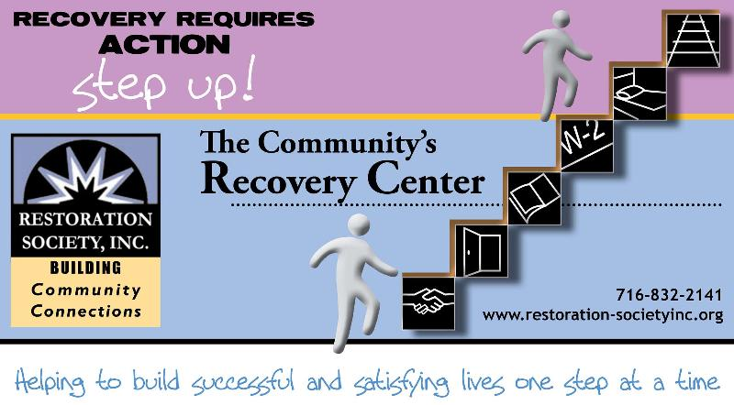

###### Restoration Society, Inc., 66 Englewood Avenue, Buffalo, NY 14214

###### [www.rsiwny.org](http://www.rsiwny.org) (716) 832-2141 Fax (716) 832-0021

Recovery Happens

January 2018

Volume 10,Issue 1

**WE ARE OPEN FOR**

**NEW YEARS DAY**

**AT EMPOWERMENT ACADEMY**

**327 ELM STREET, BUFFALO**

**10:00 am- 2:00 pm**

For more information, please call

(716)884-5216 ext. 415 or 416

**Restoration Society, Inc. is #1 In NYS State**

**in the # of people we serve**

**and # of referrals we get for**

**Home and Community**

**Based Services**

These are the services we are currently offering Erie, Genesee, and Niagara County:

* Psychosocial Rehabilitation
* Habilitation
* Family Support and Training
* Education Support Services
* Empowerment Services- Peer Supports
* Pre-vocational Services
* Transitional Employment
* Intensive Supported Employment (ISE)
* Ongoing Supported Employment

Please contact these staff people for more information on Home and Community Based Services at Restoration Society, Inc.

Genesee County – Heather Kemp, [585-343-9162, ext. 301](tel:585-343-9162%2C%20ext.%20301)

Erie and Niagara County –Fran Gullo, 716-884-5216, ext. 407

**ACE Employment Services**

**Informational Session**

January 9, 2018 at 1:30 pm

January 26, 2018 at 10:30 am

327 Elm Street Corner

of Elm and Genesee

Having a Disability Does

Not Mean You Can’t Work

Introduction to The Three Different Employment Services ACE Provides

Please Contact:

Fran Gullo (716)884-5216 Ext. 407

***Got Questions?*** Why do I need to work? Do I have enough experience? What do I want to do? Where do I start? What if I fail? How do I commit to making a change?

***WE HAVE ANSWERS!!!!***

Work Readiness Workshop

Tuesdays

10:30 -12:00 pm

Walk-Ins WELCOME!

FREE Coffee & Refreshments Provided

66 Englewood Avenue, Buffalo, NY 14214

For more information, Call Kate at (716)884-5216 ext. 410

Restoration Society, Inc. is a Certified Ticket to Work Employment Network

* Whether you are seeking full or part-time employment, we can help.
* Employment Services include advisement by certified benefits advisors and career consultations are FREE of charge!
* It only applies if you are on Social Security benefits!!!
* On or off site support, YOUR Choice

Please Contact:

Michelle Hovey (Erie County)

(716)884-5216 ext. 406

Gail McKee (Genesee County)

(585) 343-9162 ext. 307

**By, Keith**

You force to kick yourself in the butt., but before that think. Otherwise you fight. Nobody loves me. Then you think there’s no other way then to party!

**Volunteering  
By, Michelle Brown**

I would like to volunteer in either working with patients in hospitals or a cleaning position in either facility. I would like to do this after I move into my new apartment. My reason I want to volunteer is to be able to give back to the community as the community has given back to me. The pros of engaging in volunteering is to be able to freely give to others on your own terms. The cons are you may not receive compensations or pay if something happens to your situation which may be negative or pay to buy the things you need!

**Volunteering**

**By Keith**

I wouldn’t mind volunteer work. I hear a lot about volunteer work. There are two volunteer places I would be interested in. One is nursing homes, playing games, reading, and talking and listening to the folks. Another one is the SPCA for the reason being I lost a cat that was very special to me. I don’t want to own anymore animals but I would love to be around animals.

**Sonnet #1**

Loving your body is all really need. Your precious form causes my heart to weep. My love for you sealed in my need to relax, to rest, then finally sleep.  
If my mind you choose not to embrace you’d rather ponder on things divine. Baby please concentrate on my face your heart can beat without your mind.  
As I caress you in anticipation I love to watch you quiver then shake. Nothing can describe the penetration that the friction from our bodies tender to make.  
Don’t rush take it slow please don’t move too fast. Death comes all to quick let’s make our heaven last.

**Happy New Year**

**By, John**

My New Year’s Resolution is to lose 50 pounds next year. I have had success in the past with low fat diets. Cake, candy, cookies, only on holidays like Christmas, Birthdays, and Easter.

**Volunteering**

**By, John**

I was a Kaledia Health volunteer for over ten years. I was happy I was able to do something useful. At this time, I don’t want to volunteer because I am still learning how to use public transportation.

**Winter’s Journey**

The ice on the ground made the cars brake around downtown with the cold wind touching my skin like a woman. Seeing into the eyes of my soul snowflakes shatter and fall into the sub-zero that shatters. I could see my own breath as air constricts in my chest, none the less, hope for a fulfilled year, I’m tired of spending emotion on these tears, but there’s a door cracked open that God wants me to see, the journey might be long. Would you like to go with me?

**Homeless Travels  
By, Michelle**

Being homeless is a hard journey to endure because you don’t know what to expect which happens to us. For the past two years of my adult life, I have struggled to form some kind of stability in my everyday life but new things keep happening, therefore nothing stays the same, so how can you keep up?  
Support yourself when you can, seek after good people who will understand and what you’re going through, for we are faced with many problems. Keeping up with the Jones’ is staggering, hanging out with the wrong crowd gets you into a bigger problem, then you had for the first time you faced your problem in the first place.  
Survival strategies I’ve learned, taking something and making something creative out of nothing is a sure way to get through, selling yourself as being somedays successful and important in your life is a sure guarantee, you will never be homeless again because you have to let God bring you to the place where you need to be.

**Looking Forward to 2018  
By, Tim**

Already a new year is upon, 2018 has arrived and my how quickly the time has flown. Just yesterday it seemed to be July 4th and Thanksgiving Day but now a new year is upon us. To some a new year presents a daunting task but I’m personally looking forward to 2018. There are so many new opportunities for us people who suffer with a mental illness because the outright stigma that use to exist against us clients who suffer with a mental health disorder have now to a certain degree been eliminated as people are being educated on what it’s like to suffer with a mental illness. People who suffer with a mental illness are no longer being institutionalized for the degree that they once were but people who suffer with a mental illness are now seen as integral members of society so yeah I’m going to look forward to 2018 especially with the new opportunities that are in store for me as well as other mental health clients.



Legal Clinic

at the Empowerment Academy

Fourth Wednesday of Every Month

9:00 am -12:00 pm

Services for the Legal Clinic

* Social Security Disability
* Supplemental Security Income
* Housing Laws
* Family Law
* Consumer Law
* Public Assistance Matters

For more information, please call

(716)884-5216 ext. 415 or 416

**Save the Date**

**Mental Health Awareness Information Fair**

**& 6th Annual Flash Mob**

**May 3, 2018 10-1pm At Buffalo Central Library**

**Please Contact Michelle S**

**At (716)832-2141 ext. 230**

Restoration Society, Inc. (RSI) in partnership with the Lt. Colonel Matt Urban Hope Center, has been selected to operate the Code Blue program during the upcoming winter season. RSI and Matt Urban Hope Center will be joined by St. Luke's Mission of Mercy to provide accommodations and needed services at their facilities (MU Hope Center, MU Hope House shelter, St. Luke's  and RSI Harbor House)  After November 15 and before March 15, when the temperatures dips below 15F (or with the wind chill) a code blue is called. When that happens, the Harbor House, St. Luke's Mission of Mercy, and the Hope Center will open as warming shelters for the night, from 8pm to 8am.

**Code Blue 32**

The shelters at Matt Urban Hope Center and Harbor House will be open under Code Blue 32 on nights when temperatures or windchill are between 16 and 32 degrees. St. Luke's Mission of Mercy will continue to be open only under Code Blue.  The expanded safety plan also opens up a warming center at Harbor House during the daytime, so that street homeless people won't have to wander from spot to spot in the city to keep warm. Service providers also will be able to work with clients inside the center.

**My Interesting in Volunteering  
By, Jennifer**

I would like to volunteer at a job. I would like to volunteer in the areas of animals or children. I have worked with a camp that taught football skills to children and they can earn full scholarships to division I-III colleges. I see the pros of this kind of volunteer work is:  
1. Help to positively shape young minds.  
2. I help to keep young men out of jails and prisons.  
Cons of this type of volunteer work is:  
1. You or the kids can get hurt due to the extreme summer heat or broken bones.  
2. The kids get into trouble or die in the streets.  
My second choice for volunteering would be my local channel shelter. The reason why I would want to work in an animal shelter is I have a love for animals.  
Pros:  
1. I love animals and want to rescue them.  
2. That I can help homeless animals find new forever homes, with new loving families.  
3. I enrich the animals life and the animal can enrich mine.  
Cons:  
1. An animal can come into the shelter sick and need to be put to sleep.  
2. The injuries that abused animals could come into the animal shelter.  
The final place I would want to volunteer at is the Empowerment Academy snack bar.  
Pros:  
1. I learn new job skills.  
2. I make new friends.  
3. Learn new coping skills and stress reduction skills.

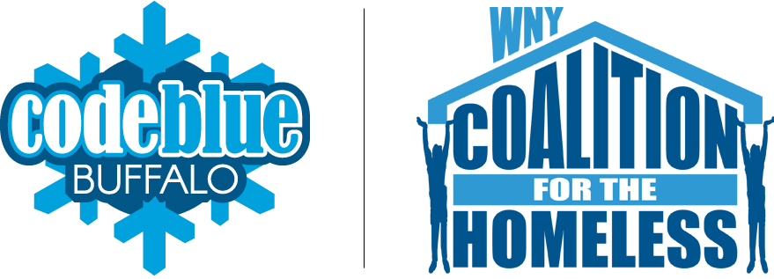

**ACE Employment and Empowerment Academy**

**327 Elm Street, 2nd Floor Buffalo, NY 14203**

**(716)884-5216**

CEO-Nancy Singh ext. 409

Executive Administrator- Kimberly Muoio ext. 402

Director of Rehabilitation Services- Fran Gullo ext. 407

EA Manager- Amanda Kopacz ext. 415

**Genesee ACE Employment**

**220 East Main Street Batavia, NY 14020**

**(585)343-9162**

Director of Programs - Genesee County

Gail McKee ext. 307

*Visit us at:*

Web site address

[www.rsiwny.org](http://www.rsiwny.org)

Facebook

[www.facebook.com/Restorationsocietyinc](http://www.facebook.com/Restorationsocietyinc)

**Administration Office, Housing Solutions**

**& Young Adult Clubhouse**

**66 Englewood Ave, Buffalo, NY 14214**

**(716)832-2141**

CFO-Sun-Ok King ext.213

COO-Kimberly Baughan ext. 215

Director of Homeless and Housing Services

Jean Bennett ext. 219

Director of Peer Services

Michelle Scheib ext. 230

Young Adult Recovery Club Manager

Marsha Tabb ext. 217

**Harbor House Resource Center**

**241 Genesee Street Buffalo, NY 14204**

**(716)842-4184**

Manager- Jacob Hoffman

Restoration Society, Inc.

66 Englewood Avenue

Buffalo, NY 14214

