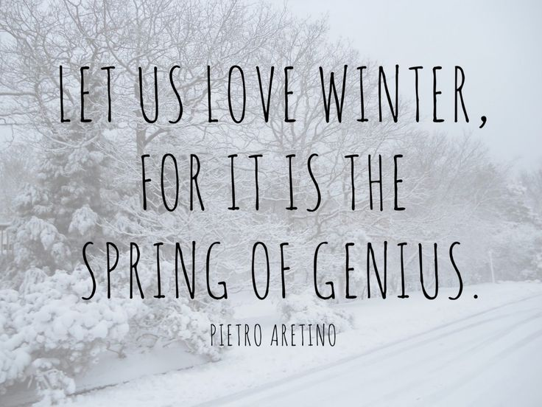

Restoration Society, Inc. programs are rehabilitation communities founded upon the recovery vision that all individuals can lead active lives filled with hope and satisfaction and make valuable contributions to our community.

A recovery, wellness and life achievement focus promotes and supports the development of new meaning and purpose in one’s life as one grows beyond the challenges.

Values

The values came from the dynamic collaborative partnership among customers, staff, administration and the Board of Directors, all of whom comprise the agency.

Respectful -  Holistic –Ethical- Optimism- Supportive- Peer Advocacy- Team Work -  Empowerment- Opportunity- Resiliency-

Integrity- Nurturing-Growth

Help to form our foundation which drives all Restoration Society, Inc. endeavors.

Mission Statement

Illuminating pathways toward opportunity, possibility, wellness and independence.

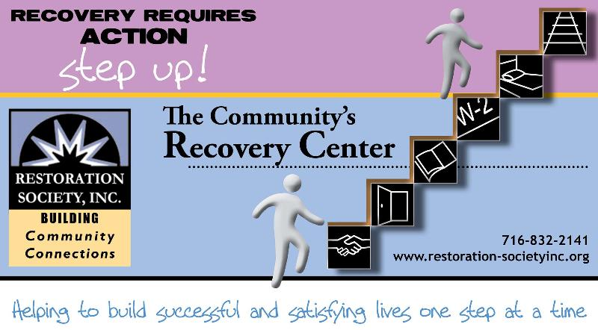

###### Restoration Society, Inc., 66 Englewood Avenue, Buffalo, NY 14214

###### [www.rsiwny.org](http://www.rsiwny.org) (716) 832-2141 Fax (716) 832-0021

Recovery Happens

December 2017

Volume 9, Issue 12

**WE ARE OPEN FOR**

**CHRISTMAS DAY**

**AT EMPOWERMENT ACADEMY**

**327 ELM STREET, BUFFALO**

**10:00 am- 2:00 pm**

For more information, please call

(716)884-5216 ext. 415 or 416

**Restoration Society, Inc. is #1 In NYS State**

**in the # of people we serve**

**and # of referrals we get for**

**Home and Community**

**Based Services**

These are the services we are currently offering Erie, Genesee, Niagara, Monroe and Orleans County:

* Psychosocial Rehabilitation
* Habilitation
* Family Support and Training
* Education Support Services
* Empowerment Services- Peer Supports
* Pre-vocational Services
* Transitional Employment
* Intensive Supported Employment (ISE)
* Ongoing Supported Employment

Please contact these staff people for more information on Home and Community Based Services at Restoration Society, Inc.

Genesee, Orleans and Monroe County – Heather Kemp, [585-343-9162, ext. 301](tel:585-343-9162%2C%20ext.%20301)

Erie and Niagara County –Fran Gullo, 716-884-5216, ext. 407

**ACE Employment Services**

**Informational Session**

December 11 , 2017 at 10:00 am

327 Elm Street Corner

of Elm and Genesee

Having a Disability Does

Not Mean You Can’t Work

Introduction to The Three Different Employment Services ACE Provides

Please Contact:

Fran Gullo (716)884-5216 Ext. 407

***Got Questions?***

Why do I need to work?

Do I have enough experience?

What do I want to do?

Where do I start?

What if I fail?

How do I commit to making a change?

Contact Work Readiness Specialist Kate Parker at [(716) 884-5216 x 410](tel:(716)%20884-5216) or [kparker@rsiwny.org](mailto:kparker@rsiwny.org).

Restoration Society, Inc. is a Certified Ticket to Work Employment Network

* Whether you are seeking full or part-time employment, we can help.
* Employment Services include advisement by certified benefits advisors and career consultations are FREE of charge!
* It only applies if you are on Social Security benefits!!!
* On or off site support, YOUR Choice

Please Contact:

Michelle Hovey (Erie County)

(716)884-5216 ext. 406

Gail McKee (Genesee County)

(585) 343-9162 ext. 307

**Christmas is Special**

**By, Tim**

Christmas is special in all of its splendor and glory. A glory that knows no bounds. Christmas is special in all of its nuances from Handel’s Messiah, that magnificent barbeque classic that glorifies the Christ child to the vast quantities of eggnog that we consume during the holiday season. The snowflakes that float past our windows to indicate that Jack Frost has returned and has brought his winter wonderland with him. Everything has been draped in a blanket of snow. Christmas is special because Christmas bells will be ringing. Carolers will be singing their happy tunes of peace and goodwill toward men and women everywhere in the world. Peace and love is at its highest aspiration in this wonderful holiday season of festive jubilations. I hope everybody has a wonderful Christmas! That’s why Christmas is so special, it’s a joy that can be shared by everyone.

**Rehab: A View from the Inside**

**By, John S.**

I am not here for a free ride; I am here because I have too much talent to hide.

**My Comfort Zone**

**By, Richard**

My comfort zone is my craftmatic bed given to me over Facebook. I love the fact of it being able to function the head up for elevation and my feet get raised up for my comfort, health, and well-being. The massaging button is used for my personal health and well-being as well. I would fear losing it altogether. Having loss of a bed for my mental health and well-being. I also would not be able to get massaged if it becomes lost or stolen or plainly runs right down to nothing. It was a gift to me and would have been thrown out.

**How to Change My Life**

**By, Michael**

1.Not to tell anymore lives.  
2. Go to mental health court every month.  
3. Stay out of trouble.  
4. Making new friends to talk to with getting stress out.  
5. Help me with my fears.  
6. Get along with others without fighting and stay calm, cool, and collective.  
7. Change my attitude with staff at the Harbor House and Empowerment Academy.

**Something I Want to Change for my Goal(s)**

**By, Brian**

I went to Florida with my family for my brother’s sixteenth birthday. That was a great time to build feelings with relatives. This was an opportunity for me to grow and work with one other.

**Things I Can and Will Change**

**By, Patricia**

I would like to do something differently concerning my health. Change my eating habits to be much healthier then it is. Now that it has been mentioned about affirmations, when I get a moment I plan to do this. I’ve written them before but that was years ago. I must learn to like myself then love myself enough not to be put in the position of being in another violent and controlling relationship. I plan to see a psychiatrist and receive counseling. I plan to get a nice apartment or small house and it will be pet friendly! Preferably a small house with a small fenced in yard. Eventually, I plan to go on trips to far away tropical islands. Maybe also Canada!

**Things I Cannot Change**

A new Children’s Hospital opens next month at the medical corridor in downtown Buffalo. I hope the restaurants on Elmwood Avenue do not go out of business when Women’s and Children’s Hospital closes for good.

**My Greatest Fears**

**By, Michael Aquino**

Making new friends that helps me from being stressed out. I’m engaged to my girlfriend Susan for six years. I have fourteen backpacks and two gym bags of clothes plus furniture before moving in our new home. Tuesday through Friday Susan and I go to North Buffalo Community Center for lunch and bingo. Friday night I go to Knights of Columbus; bingo starts at 7:30pm and lets out between 9-10pm. I like to go to the Regal Theater on week days and weekends for a movie or two.

**Comfort Zones**

**By, Trish**

I have two comfort zones, the first one is humor. In thinking about it, is humor what I hide behind because just being me without it is not acceptable it seems? Acceptance evaded me in my younger years with family. How I thought I had gained their acceptance was through humor, by accident not intentional. It began with a fall down the stairs and the way I did it that caused everyone to burst into laughter. I was in elementary school years later it became apparent they weren’t laughing with me but at me. The second comfort zone was my bedroom. Although this is where I was sent most of time, I began to embrace it and use it rather than resent it. It was here I became the most creative. I taught myself how to read and developed this school to a higher grade reading level. I began painting and drawing. My passion was reading comic books. I loved them because they were my only escape from a violent existence. The Silver Surfer was my favorite because he traveled to far and distant galaxies and I fantasized I rode with him.   
My comfort zones which were originally designed as one making fun of me and the other a place of isolation, rejection, and punishment, a negative to a positive. When you have lemons, you make lemonade!

**Future Goals**

**By, Pat Donhan**

Recently moved to Buffalo, New York from Orange County. I live in my uncle’s house in Westtown, moved out and got my own apartment in Middletown. I worked as a carpenter for my uncle and hope to get some kind of job referral for a handyman or carpenter worker in Buffalo. If not, I’ll try stock work in a store. I’m currently looking for housing.

**Things I Can Change**

**By, Dennis**

Things I can change are my ways. The way I do things without total control and discipline. The way I live in reference of how I do and behave to general rules, laws, and regulations. For example, don’t be believe what everyone says or does. Don’t react on impulse such as speed. Behavior without thought or common sense! A violation would be considered Satan verses God which one is good or evil!  
Sometimes we have to allow time out to get back to a normal way of thinking and basic common sense. The expected behavior from the jump start being original and true to what’s real of being realistic and simplistic. The general and down to Earth way of achieving and solving spiritual and physical problems.  
Things to be done is stop being lazy and mentally fatigue about general rights struggles. Going to make amends toward loved ones having merry and consideration. Bringing about unity, harmony, and respect. Respect is very important in trying to achieve and make progress of the family legacy of accomplishments.  
To read more and exercise instead of watching television and gambling that’s chances and assumptions which are unreasonable.  
Get to know, respect, and respond to God our Lord and Savior. “The Magnification” always true and faithful!

I want to change my life by going to school and getting a diploma. I will start classes and finish then that way I can find and have a job I enjoy and like.

**Save the Date**

**Mental Health Awareness Information Fair**

**& 6th Annual Flash Mob**

**May 3, 2018 10-1pm At Buffalo Central Library**

**Please Contact Michelle S**

**At (716)832-2141 ext. 230**

Legal Clinic

at the Empowerment Academy

Fourth Wednesday of Every Month

9:00 am -12:00 pm

Services for the Legal Clinic

* Social Security Disability
* Supplemental Security Income
* Housing Laws
* Family Law
* Consumer Law
* Public Assistance Matters

For more information, please call

(716)884-5216 ext. 415 or 416

**Need Help Making Ends Meet at The Holiday’s?**

**The WNY Holiday Partnership is Here!**

**Families who are eligible for SNAP**

**Can receive toys and gifts for**

**their children 12 and younger!**

**Applications will be accepted**

**October 23- December 8**

**For Information about how to apply, and application locations, dates, and times**

**Call 2-1-1 or 888-6969211**

Restoration Society, Inc. (RSI) in partnership with the Lt. Colonel Matt Urban Hope Center, has been selected to operate the Code Blue program during the upcoming winter season. RSI and Matt Urban Hope Center will be joined by St. Luke's Mission of Mercy to provide accommodations and needed services at their facilities (MU Hope Center, MU Hope House shelter, St. Luke's  and RSI Harbor House)  After November 15 and before March 15, when the temperatures dips below 15F (or with the wind chill) a code blue is called. When that happens, the Harbor House, St. Luke's Mission of Mercy, and the Hope Center will open as warming shelters for the night, from 8pm to 8am.

**Code Blue 32**

The shelters at Matt Urban Hope Center and Harbor House will be open under Code Blue 32 on nights when temperatures or windchill are between 16 and 32 degrees. St. Luke's Mission of Mercy will continue to be open only under Code Blue.  The expanded safety plan also opens up a warming center at Harbor House during the daytime, so that street homeless people won't have to wander from spot to spot in the city to keep warm. Service providers also will be able to work with clients inside the center.

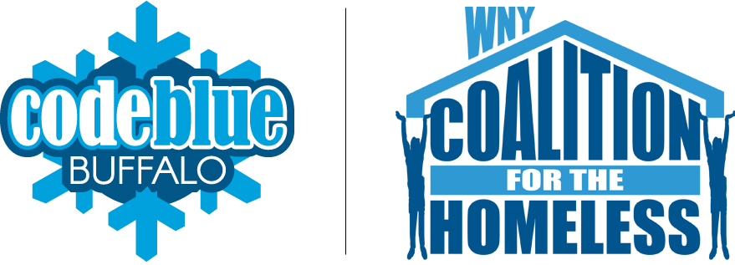

**ACE Employment and Empowerment Academy**

**327 Elm Street, 2nd Floor Buffalo, NY 14203**

**(716)884-5216**

CEO-Nancy Singh ext. 409

Executive Administrator- Kimberly Muoio ext. 402

Director of Rehabilitation Services- Fran Gullo ext. 407

EA Manager- Amanda Kopacz ext. 415

**Genesee ACE Employment**

**220 East Main Street Batavia, NY 14020**

**(585)343-9162**

Director of Programs - Genesee County

Gail McKee ext. 307

**Administration Office, Housing Solutions**

**& Young Adult Clubhouse**

**66 Englewood Ave, Buffalo, NY 14214**

**(716)832-2141**

CFO-Sun-Ok King ext.213

COO-Kimberly Baughan ext. 215

Director of Homeless and Housing Services

Jean Bennett ext. 219

Director of Peer Services

Michelle Scheib ext. 230

Young Adult Recovery Club Manager

Marsha Tabb ext. 217

**Harbor House Resource Center**

**241 Genesee Street Buffalo, NY 14204**

**(716)842-4184**

Manager- Jacob Hoffman

*Visit us at:*

Web site address

[www.rsiwny.org](http://www.rsiwny.org)

Facebook

[www.facebook.com/Restorationsocietyinc](http://www.facebook.com/Restorationsocietyinc)

Restoration Society, Inc

66 Englewood Avenue

Buffalo, NY 14214

