

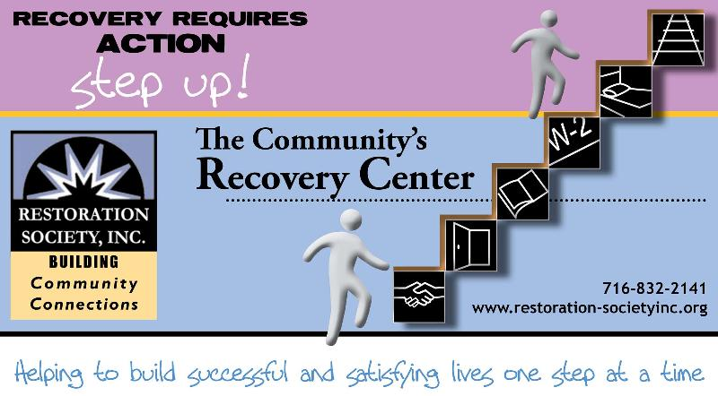

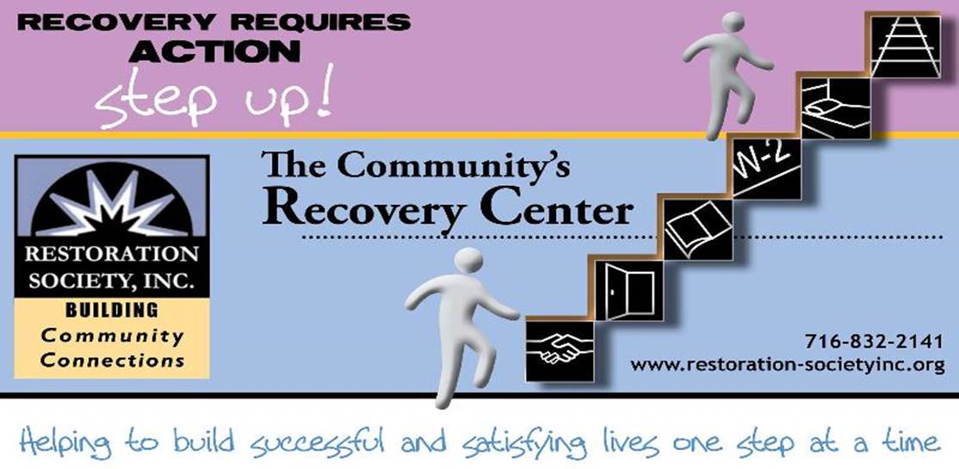

**716-832-2141**

**www.rsiwny.org**

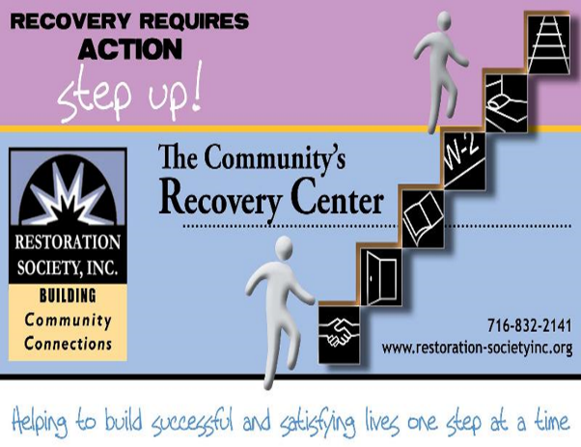

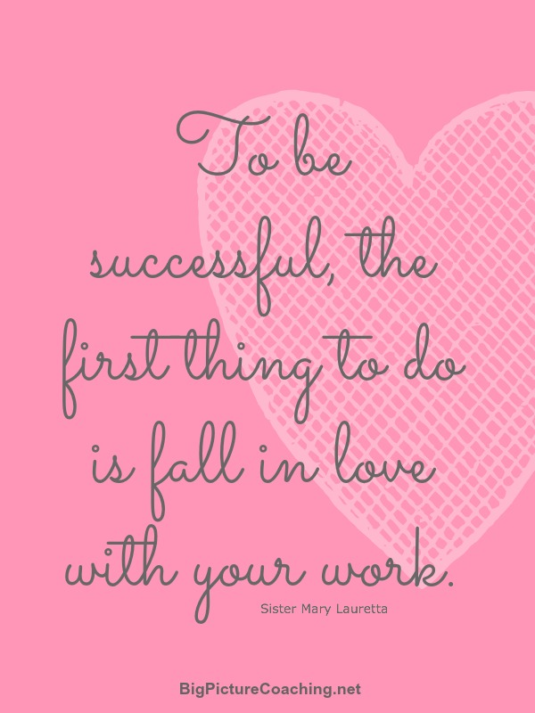

Restoration Society, Inc. programs are rehabilitation communities founded upon the recovery vision that all individuals can lead active lives filled with hope and satisfaction and make valuable contributions to our community.

A recovery, wellness and life achievement focus promotes and supports the development of new meaning and purpose in one’s life as one grows beyond the challenges.

Values

The values came from the dynamic collaborative partnership among customers, staff, administration and the Board of Directors, all of whom comprise the agency.

Respectful -  Holistic –Ethical- Optimism- Supportive- Peer Advocacy- Team Work -  Empowerment- Opportunity- Resiliency-

Integrity- Nurturing-Growth

Help to form our foundation which drives all Restoration Society, Inc. endeavors.

Mission Statement

Illuminating pathways toward opportunity, possibility, wellness and independence.

###### Restoration Society, Inc., 66 Englewood Avenue, Buffalo, NY 14214

###### [www.rsiwny.org](http://www.rsiwny.org) (716) 832-2141 Fax (716) 832-0021

Recovery Happens

February 2018

Volume 10,Issue 2

Legal Clinic

at the Empowerment Academy

Fourth Wednesday of Every Month

9:00 am -12:00 pm

Services for the Legal Clinic

* Social Security Disability
* Supplemental Security Income
* Housing Laws
* Family Law
* Consumer Law

For more information, please call

(716)884-5216 ext. 415 or 416

**Restoration Society, Inc. is #1 In NYS State**

**in the # of people we serve**

**and # of referrals we get for**

**Home and Community**

**Based Services**

These are the services we are currently offering Erie, Genesee, and Niagara County:

* Psychosocial Rehabilitation
* Habilitation
* Family Support and Training
* Education Support Services
* Empowerment Services- Peer Supports
* Pre-vocational Services
* Transitional Employment
* Intensive Supported Employment (ISE)
* Ongoing Supported Employment

Please contact these staff people for more information on Home and Community Based Services at Restoration Society, Inc.

Genesee County – Heather Kemp, [585-343-9162, ext. 301](tel:585-343-9162%2C%20ext.%20301)

Erie and Niagara County –Fran Gullo, 716-884-5216, ext. 407

**ACE Employment Services**

**Informational Session**

February 5, 2018 at 1:30 pm

February 23, 2018 at 10:30 am

327 Elm Street Corner

of Elm and Genesee

Having a Disability Does

Not Mean You Can’t Work

Introduction to The Three Different Employment Services ACE Provides

Please Contact:

Fran Gullo (716)884-5216 Ext. 407

***Got Questions?*** Why do I need to work? Do I have enough experience? What do I want to do? Where do I start? What if I fail? How do I commit to making a change?

***WE HAVE ANSWERS!!!!***

Work Readiness Workshop

Tuesdays

10:30 -12:00 pm

Walk-Ins WELCOME!

FREE Coffee & Refreshments Provided

66 Englewood Avenue, Buffalo, NY 14214

For more information, Call Kate at (716)884-5216 ext. 410

Restoration Society, Inc. is a Certified Ticket to Work Employment Network

* Whether you are seeking full or part-time employment, we can help.
* Employment Services include advisement by certified benefits advisors and career consultations are FREE of charge!
* It only applies if you are on Social Security benefits!!!
* On or off site support, YOUR Choice

Please Contact:

Michelle Hovey (Erie County)

(716)884-5216 ext. 406

Gail McKee (Genesee County)

(585) 343-9162 ext. 307

**My Dreams for the Rest of my Life  
By, Reginald**

1.Start saving money  
2. See my parents live to see 115 years  
3. See my daughters grow up to be successful  
4. Never go back to jail or prison  
5. Have and own my own home for life  
5. To be financially stable for life

**My Dreams for the Future  
By, Dennis**

I want to live and have freedom to do what I want. Preferably what’s working; is it okay or not? I want to be totally independent not dependent. There is a difference. One overrides the other. It can turn out to be stressful, especially when you are trying to focus on reality and seeing things the way they are and not pretending to be. I want to be mentally and physically able to help someone without looking for anything back in return. What I’m aiming at is a civilized and concern citizen that feels the pain, pressures, and needs without being over aggressive and demanding. Talking about a good Samaritan for real. To pray to God to give me the strength and wisdom to live life one day at a time.

**What Are My Fears and How to Deal With Them  
By, Brian Kitson**

During my early life, I had been sheltered from life and sooner or later I needed to overcome my disposition. Too much was on my family and I don’t have time for myself. Some people take advantage of my niceness.

**My Dreams for the Future  
By, Keith Cowles**

My dreams for life are to focus on the right things for my life. Live comfortable and pay more attention on certain thing that may help my future a lot more. First thing I need to do is grab my TASC diploma and focus on myself and not so much on others.

**Mental Illness  
By, Keith**

Mental illness; I never knew how major it is or how many people experience it and that there is a lot of help out in the world and support.

About eight months ago I was living in Albany, New York and when you were on social security and were homeless, they would put you in a shelter for thirty days or however long you were to stay. Well after the new President took over, they came up with they were not allowed to shelter people with social security. During that time, I constantly had to sleep in the mission or on the streets or a friend’s house. It was very stressful being without shelter for me and the guys over there during that time. I had time to think, gain, and become stronger and learned not to give up. Now after everything from there, it got me through tough times that were ahead. I just recently became homeless here in Buffalo and found a new home. Going through all of the tough times got me through all the other days that were truly embarrassing and tough.

**How to Celebrate Valentine’s Day  
By, Michael**

Sending Valentine’s cards to all staff workers at Empowerment Academy and most Urban workers; they are like family to me. It makes me happy I get along with everybody.

Most of all, my best experience has been the bad and good of mental health. Many memories have been had despite the system. There was a time when I elected not to have electroshock therapy. Much experience was had for over forty years. Now I have a gift to help others.



**Valentine’s Day**

**By, Rashene T.**

I went to a Valentine’s Day party with my group home when I lived back in Charlotte. I use to go to Valentine’s Day parties when I was a child in grade school. My boyfriend and I exchanged cards among ourselves on Valentine’s Day.

**Fears**

**By, Anonymous**

A fear that I had in my life at one point was that I was afraid of my ex-husband because of the abuse that he put me through. I managed to finally stand up to him and tell him what a piece of crap he is. That he can’t abuse me anymore. I stood up to him and left, now I am safe.

**Fears**

**By, Dennis Davis**

One of my fears is afraid to reach out to people; interacting and talking to people. Giving them useful advice to help them solve their problems. Fear of being prejudice. What I approve of what and what I don’t approve of. Some people are more favorable than others. Depending on your social status and the people you hang around or are involved with. Fear of not being yourself instead of somebody else. You are who you are face it and accept it, be original. The old traditional made it all possible. It’s the first chapter of living a successful lifestyle, in peace and harmony for all mankind. It goes back to how we were raised from our parents. I’m talking about the good fight or evil nature in man kindness spirit. It can be good or bad!

**To Overcome my Depression  
By, Anoymous**

My father said I will be on medication for the rest of my life. However, my parents have both passed away. I now have a goal to honor my parents. Also I have a problem with paranoid schizophrenia. Most of all I work with staff and/or peers. This requires cooperating with both groups then I need to become myself to spread my wings and fly. Also I need to forgive myself as I do others.

**Save the Date**

**Mental Health Awareness Information Fair**

**& 6th Annual Flash Mob**

**May 3, 2018 10-1pm At Buffalo Central Library**

**Please Contact Michelle S**

**At (716)832-2141 ext. 230**

Restoration Society, Inc. (RSI) in partnership with the Lt. Colonel Matt Urban Hope Center, has been selected to operate the Code Blue program during the upcoming winter season. RSI and Matt Urban Hope Center will be joined by St. Luke's Mission of Mercy to provide accommodations and needed services at their facilities (MU Hope Center, MU Hope House shelter, St. Luke's  and RSI Harbor House)  After November 15 and before March 15, when the temperatures dips below 15F (or with the wind chill) a code blue is called. When that happens, the Harbor House, St. Luke's Mission of Mercy, and the Hope Center will open as warming shelters for the night, from 8pm to 8am.

**Code Blue 32**

The shelters at Matt Urban Hope Center and Harbor House will be open under Code Blue 32 on nights when temperatures or windchill are between 16 and 32 degrees. St. Luke's Mission of Mercy will continue to be open only under Code Blue.  The expanded safety plan also opens up a warming center at Harbor House during the daytime, so that street homeless people won't have to wander from spot to spot in the city to keep warm. Service providers also will be able to work with clients inside the center.

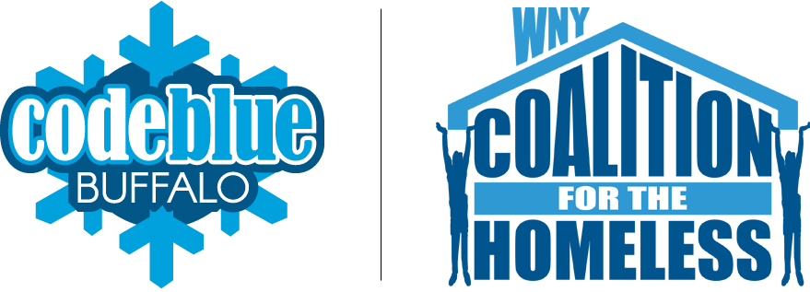

**ACE Employment and Empowerment Academy**

**327 Elm Street, 2nd Floor Buffalo, NY 14203**

**(716)884-5216**

CEO-Nancy Singh ext. 409

Executive Administrator- Kimberly Muoio ext. 402

Director of Rehabilitation Services- Fran Gullo ext. 407

EA Manager- Amanda Kopacz ext. 415

**Genesee ACE Employment**

**220 East Main Street Batavia, NY 14020**

**(585)343-9162**

Director of Programs - Genesee County

Gail McKee ext. 307

*Visit us at:*

Web site address

[www.rsiwny.org](http://www.rsiwny.org)

Facebook

[www.facebook.com/Restorationsocietyinc](http://www.facebook.com/Restorationsocietyinc)

**Administration Office, Housing Solutions**

**& Young Adult Clubhouse**

**66 Englewood Ave, Buffalo, NY 14214**

**(716)832-2141**

CFO-Sun-Ok King ext.213

COO-Kimberly Baughan ext. 215

Director of Homeless and Housing Services

Jean Bennett ext. 219

Director of Peer Services

Michelle Scheib ext. 230

Young Adult Recovery Club Manager

Marsha Tabb ext. 217

**Harbor House Resource Center**

**241 Genesee Street Buffalo, NY 14204**

**(716)842-4184**

Manager- Jacob Hoffman

Restoration Society, Inc.

66 Englewood Avenue

Buffalo, NY 14214

