

Restoration Society, Inc. programs are rehabilitation communities founded upon the recovery vision that all individuals can lead active lives filled with hope and satisfaction and make valuable contributions to our community.

A recovery, wellness and life achievement focus promotes and supports the development of new meaning and purpose in one’s life as one grows beyond the challenges.

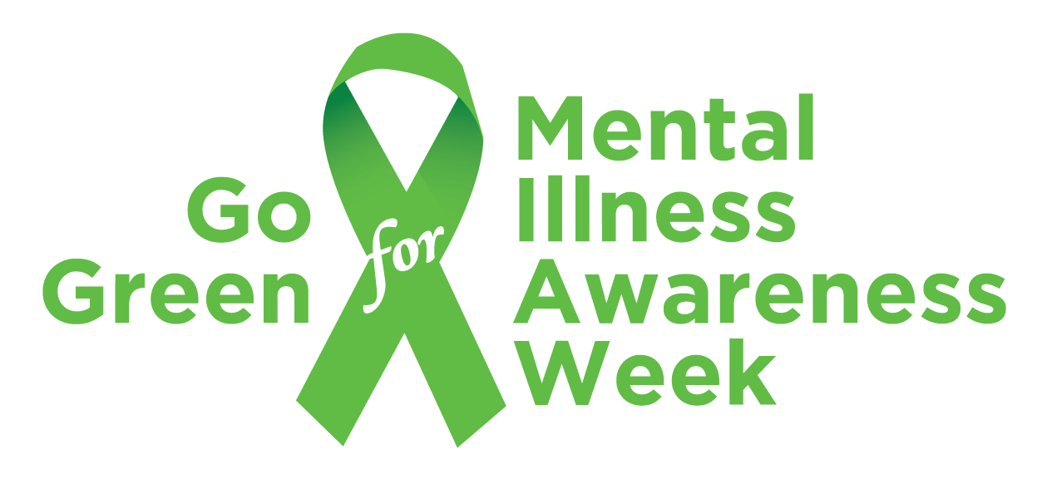

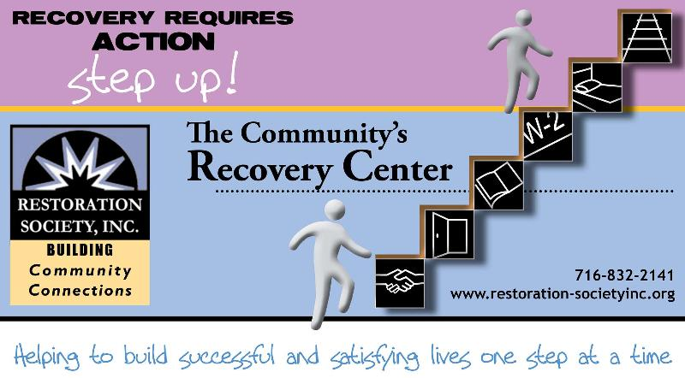

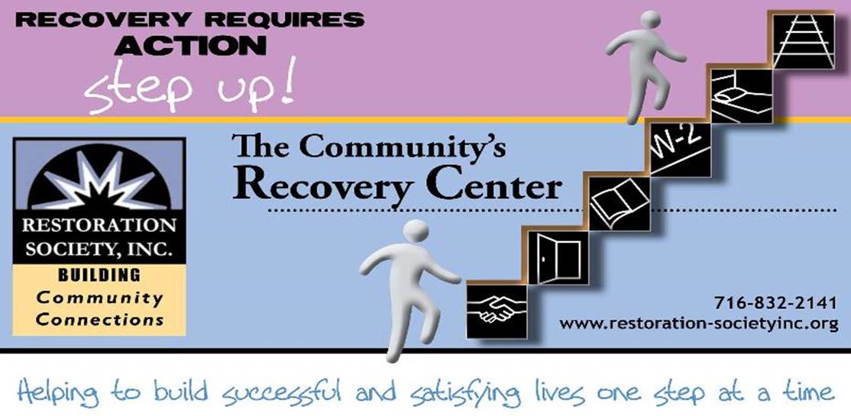

**716-832-2141**

**www.rsiwny.org**

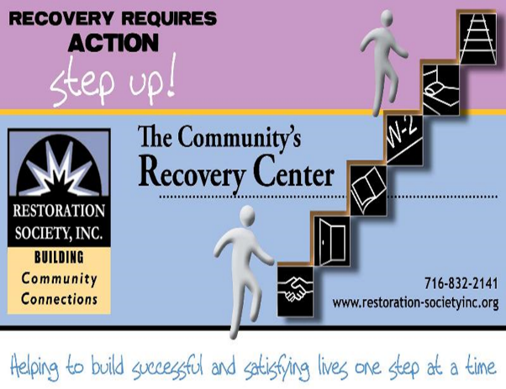

Values

The values came from the dynamic collaborative partnership among customers, staff, administration and the Board of Directors, all of whom comprise the agency.

Respectful -  Holistic –Ethical- Optimism- Supportive- Peer Advocacy- Team Work -  Empowerment- Opportunity- Resiliency-

Integrity- Nurturing-Growth

Help to form our foundation which drives all Restoration Society, Inc. endeavors.

Mission Statement

Illuminating pathways toward opportunity, possibility, wellness and independence.

###### Restoration Society, Inc., 66 Englewood Avenue, Buffalo, NY 14214

###### [www.rsiwny.org](http://www.rsiwny.org) (716) 832-2141 Fax (716) 832-0021

Recovery Happens

May 2018

Volume 10, Issue 5

***Got Questions?*** Why do I need to work? Do I have enough experience? What do I want to do? Where do I start? What if I fail? How do I commit to making a change?

***WE HAVE ANSWERS!!!!***

Work Readiness Workshop

Tuesdays

10:30 -12:00 pm

Walk-Ins WELCOME!

FREE Coffee & Refreshments Provided

66 Englewood Avenue, Buffalo, NY 14214

For more information, Call Kate at (716)884-5216 ext. 410

No Class on May 22nd and 5/29

Legal Clinic

at the Empowerment Academy

Fourth Wednesday of Every Month

9:00 am -12:00 pm

Services for the Legal Clinic

* Social Security Disability
* Supplemental Security Income
* Housing Laws
* Family Law
* Consumer Law

For more information, please call

(716)884-5216 ext. 415 or 416

**Restoration Society, Inc. is #1 In NYS State**

**in the # of people we serve**

**and # of referrals we get for**

**Home and Community**

**Based Services**

These are the services we are currently offering Erie, Genesee, and Niagara County:

* Psychosocial Rehabilitation
* Habilitation
* Family Support and Training
* Education Support Services
* Empowerment Services- Peer Supports
* Pre-vocational Services
* Transitional Employment
* Intensive Supported Employment (ISE)
* Ongoing Supported Employment

Please contact these staff people for more information on Home and Community Based Services at Restoration Society, Inc.

Genesee County – Heather Kemp, [585-343-9162, ext. 301](tel:585-343-9162%2C%20ext.%20301)

Erie and Niagara County –Fran Gullo, 716-884-5216, ext. 407

**ACE Employment Services**

**Informational Session**

May 8th, 2018 at 1:30 pm

May 25, 2018 at 10:30am

327 Elm Street Corner

of Elm and Genesee

Having a Disability Does

Not Mean You Can’t Work

Introduction to The Three Different Employment Services ACE Provides

Please Contact:

Fran Gullo (716)884-5216 Ext. 407

Restoration Society, Inc. is a Certified Ticket to Work Employment Network

* Whether you are seeking full or part-time employment, we can help.
* Employment Services include advisement by certified benefits advisors and career consultations are FREE of charge!
* It only applies if you are on Social Security benefits!!!
* On or off site support, YOUR Choice

Please Contact:

Michelle Hovey (Erie County)

(716)884-5216 ext. 406

Gail McKee (Genesee County)

(585) 343-9162 ext. 307

**Childhood Trauma and Mental Illness (Part II)  
By, Tim M.**

In part I, I addressed the correlation between childhood trauma and mental illness and its narrowing effects. Now in part II, I’m finding to give some tips as to how mental health clients can learn to cope from the problems and harrowing effects of being subjected to childhood trauma.  
 Letting go. It’s hard don’t get me wrong but when you can come to the realization that letting go maybe good or possibly the best advice because the person who hurt you in the past so if the person who hurt you in the past realizes that they can still control you if you let them so try to let go a good way to let go regarding the person who hurt you is try to utilize the phrase out of sight out of mind and try your best to get on with your life.  
 Talk to someone who understands what you’re going through an understanding person who really cares could really change your life.  
 Other tips such as visualization is great because it gets your mind off of the past and on the here and now so go and utilize these and get on with life!

**When I Don’t Feel Good  
By, Jen D.**

When I don’t feel good I want to stay in bed. I can’t eat all I do is sleep and not eat. I also want to rest with the one I love.

Hello world. God Bless you all. I have a dream. In regards of our young generations. What about the same day… The same time. Once a month all the churches in the world! Pray and praise God over our future children. As well once a month with prayers. Let go white balloons. All this for our young generation, praise God.

**Today   
By, Tim M.**

Today is not yesterday but today is the present reality in which we have opportunities for a brighter future. A future in which we will become a great success in society but we will live for today and not for yesterday because today we plan for our future because our future is today so that our tomorrows will be a big success. Because today is the present reality in which we have opportunities for a brighter future. A future in which we will become a great success. A success that’s not predicted on our yesterday’s we will have our success in life because we live for today which is the present reality and that’s the greatest success anyone can wish to hope for.

Another usual month- mental health awareness. Same as the year before. For example, may the weather could be good or bad. That is why they call it May. Whether or not the weather, the change will happen. Some people may say that around here the best month to catch rays would be the Mays. Now there are opportunities for some different months could be named as the mental health month. Such as months like September, November, and December as a time to remember. These memories could help the mental health. However, I like May for when is now. Also, I prefer May as a time to feel better with renewal or rejuvenation after a season of snow and cold, depression. This will be to turn a season from spring to summer. Yet a season of reverence will change with time. Last but not least (the definitely not least) but Jay Gilpatrick will be sorely missed. His last work day is Friday, April 6th 2018. Now he will officially retire on this date. Let us all say thank you and best of luck Jay!

**Save the Date**

**Mental Health Awareness Information Fair**

**& 6th Annual Flash Mob**

**May 3, 2018 10-1pm At Buffalo Central Library**

**Please Contact Michelle S**

**At (716)832-2141 ext. 230**

**No More Yesterdays  
By, Tim M.**

As we look forward to success today and even better recovery tomorrow and keep our backs turned to the past because the emphasis should be on no more yesterdays. Because the yesterdays of our life kept us from achieving our goals for today so now it’s today, tomorrow, and the future that we should be looking forward not to yesterday and keep our backs turned to the past. Because the emphasis should be on no more yesterdays as we look forward to success today and even better recovery tomorrow be we can only achieve these things in life if we emphasize no more yesterdays.

**By, John S.**

Just another May as a mental health

Just another May as a mental health awareness month. Now to use our skills and justify ourselves to May’s changes. Some people say other months who would be an answer. However, I feel strongly that May would be best as say months. Also, not only a time of change in weather this calendar to renewal and spring will happen. Again people have their own opinions with regards to a season of spring. Some people would have the four seasons to renewal, relaxation, and reflection.

Jay is a high functioning, skilled worker. I will miss his classes.

**A Tribute to Jay Gilpatrick  
By, Brian K.**

If someone would know him, he would be a valuable asset. However, Jay Gilpatrick will be sorely missed. His last work day is Friday, April 6th, 2018. Now, he will officially retire on the date. Let us give a good thank you and best of luck to Jay!

August 25, 2018

6:00 - 10:00 pm

D’Avolio

5409 Main St Williamsville, NY 14221

We are hosting this event to help other individuals and businesses give back to the community in which we live. We invite you to this wonderful event with hopes of surpassing last year’s record of giving, and making a positive impact in the lives of those around us that are in need. Purchase a $25.00 ticket for the event and enjoy an evening of great food, entertainment, and prizes.

**To purchase tickets, sponsor the event, or to make a donation, please call Sally at Sutton Architecture…716-932-7156!**

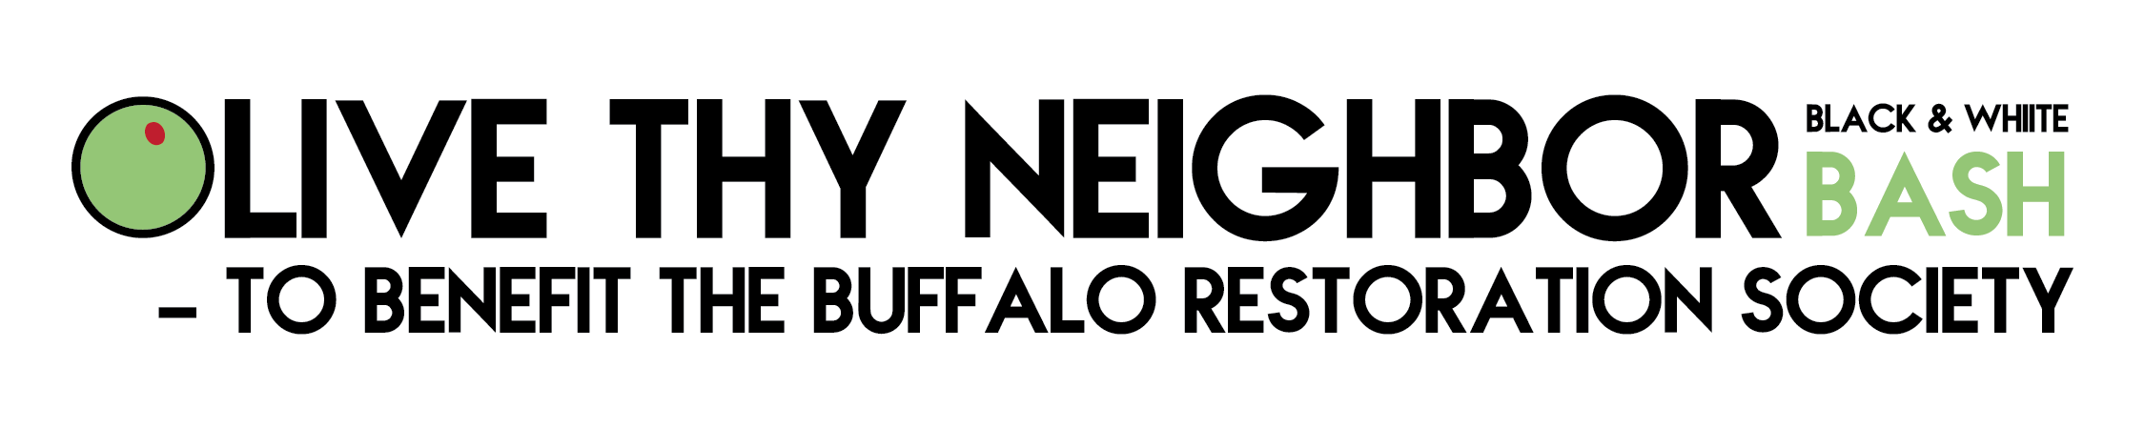

**ACE Employment and Empowerment Academy**

**327 Elm Street, 2nd Floor Buffalo, NY 14203**

**(716)884-5216**

CEO-Nancy Singh ext. 409

Executive Administrator- Kimberly Muoio ext. 402

Director of Rehabilitation Services- Fran Gullo ext. 407

EA Manager- Amanda Kopacz ext. 415

**Genesee ACE Employment**

**220 East Main Street Batavia, NY 14020**

**(585)343-9162**

Director of Programs - Genesee County

Gail McKee ext. 307

*Visit us at:*

Web site address

[www.rsiwny.org](http://www.rsiwny.org)

Facebook

[www.facebook.com/Restorationsocietyinc](http://www.facebook.com/Restorationsocietyinc)

**Administration Office, Housing Solutions**

**& Young Adult Clubhouse**

**66 Englewood Ave, Buffalo, NY 14214**

**(716)832-2141**

CFO-Sun-Ok King ext.213

COO-Kimberly Baughan ext. 215

Director of Homeless and Housing Services

Jean Bennett ext. 219

Director of Peer Services

Michelle Scheib ext. 230

Young Adult Recovery Club Manager

Marsha Tabb ext. 217

**Harbor House Resource Center**

**241 Genesee Street Buffalo, NY 14204**

**(716)842-4184**

Manager- Jacob Hoffman

Restoration Society, Inc.

66 Englewood Avenue

Buffalo, NY 14214

