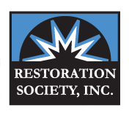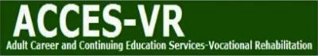

Monday December 11th at 10 am

**327 Elm Street, Buffalo, NY 14203 716-884-5216 www.restoration-societyinc.org**

Join us…

327 Elm Street – Corner of

Elm and Genesee

**Informational Forum**

**• INTRODUCTION TO THE THREE DIFFERENT EMPLOYMENT SERVICES ACE PROVIDES**

We work with ACCES-VR to provide two different services tailored to your needs as well as the Social Security Administration for TICKET TO WORK.

**• LEARN ABOUT HOW TO GET REGISTERED**

ACE will guide you through the process of how to get linked for services to help you with your goal of working!

**• GET INFORMATION ON OTHER SERVICES PROVIDED**

For 40 years, Restoration Society, Inc. has been providing services to assist individuals with Mental Illness who reside in Erie County!

ACE Employment Services

Let our team of vocational specialist’s help you get a job and earn money!  Our team, comprised of a Job Developer, Job Coaches, Life Coaches, Certified Benefits Advisors, and Rehab Practitioners are eager to help you reach your goals.  We offer a range and continuum of vocational rehabilitation services that assist customers to choose, get and maintain competitive employment positions.

WHAT YOU’LL LEARN

HAVING A DISABLITY DOES NOT MEAN YOU CAN’T WORK.