

Restoration Society, Inc. programs are rehabilitation communities founded upon the recovery vision that all individuals can lead active lives filled with hope and satisfaction and make valuable contributions to our community.

A recovery, wellness and life achievement focus promotes and supports the development of new meaning and purpose in one’s life as one grows beyond the challenges.



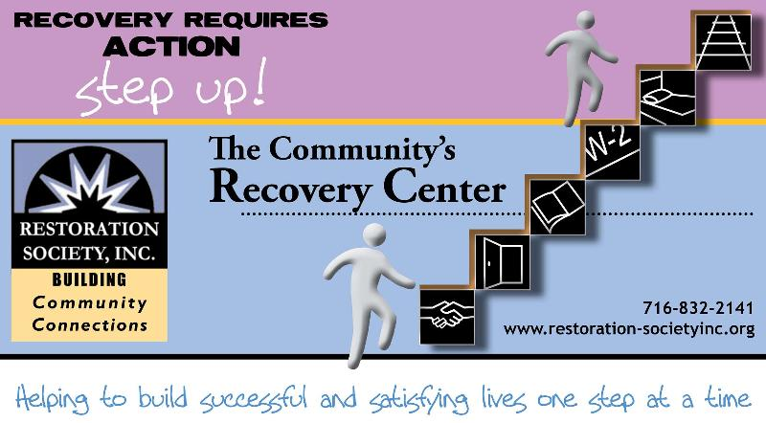

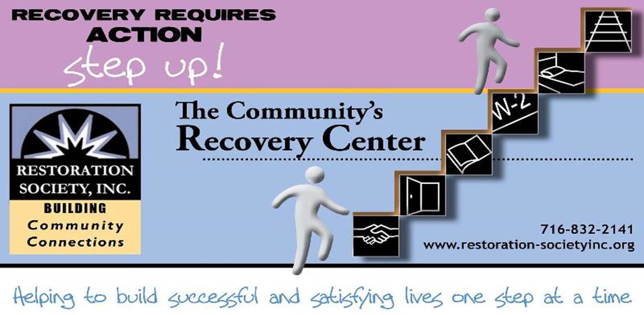

**716-832-2141**

**www.rsiwny.org**

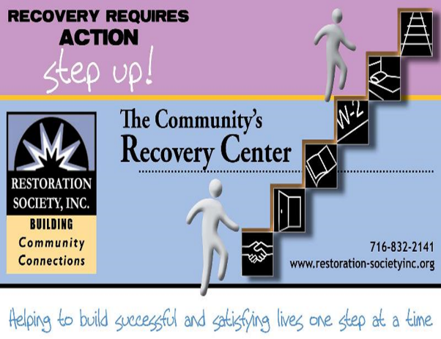

Values

The values came from the dynamic collaborative partnership among customers, staff, administration and the Board of Directors, all of whom comprise the agency.

Respectful -  Holistic –Ethical- Optimism- Supportive- Peer Advocacy- Team Work -  Empowerment- Opportunity- Resiliency-

Integrity- Nurturing-Growth

Help to form our foundation which drives all Restoration Society, Inc. endeavors.

Mission Statement

Illuminating pathways toward opportunity, possibility, wellness and independence.

###### Restoration Society, Inc., 66 Englewood Avenue, Buffalo, NY 14214

###### [www.rsiwny.org](http://www.rsiwny.org) (716) 832-2141 Fax (716) 832-0021

Recovery Happens

April 2018

Volume 10, Issue 4

***Got Questions?*** Why do I need to work? Do I have enough experience? What do I want to do? Where do I start? What if I fail? How do I commit to making a change?

***WE HAVE ANSWERS!!!!***

Work Readiness Workshop

Tuesdays

10:30 -12:00 pm

Walk-Ins WELCOME!

FREE Coffee & Refreshments Provided

66 Englewood Avenue, Buffalo, NY 14214

For more information, Call Kate at (716)884-5216 ext. 410

NO CLASS ON 4/3

Legal Clinic

at the Empowerment Academy

Fourth Wednesday of Every Month

9:00 am -12:00 pm

Services for the Legal Clinic

* Social Security Disability
* Supplemental Security Income
* Housing Laws
* Family Law
* Consumer Law

For more information, please call

(716)884-5216 ext. 415 or 416

**Restoration Society, Inc. is #1 In NYS State**

**in the # of people we serve**

**and # of referrals we get for**

**Home and Community**

**Based Services**

These are the services we are currently offering Erie, Genesee, and Niagara County:

* Psychosocial Rehabilitation
* Habilitation
* Family Support and Training
* Education Support Services
* Empowerment Services- Peer Supports
* Pre-vocational Services
* Transitional Employment
* Intensive Supported Employment (ISE)
* Ongoing Supported Employment

Please contact these staff people for more information on Home and Community Based Services at Restoration Society, Inc.

Genesee County – Heather Kemp, [585-343-9162, ext. 301](tel:585-343-9162%2C%20ext.%20301)

Erie and Niagara County –Fran Gullo, 716-884-5216, ext. 407

**ACE Employment Services**

**Informational Session**

April 10th, 2018 at 1:30 pm

April 27th , 2018 at 10:30 am

327 Elm Street Corner

of Elm and Genesee

Having a Disability Does

Not Mean You Can’t Work

Introduction to The Three Different Employment Services ACE Provides

Please Contact:

Fran Gullo (716)884-5216 Ext. 407

Restoration Society, Inc. is a Certified Ticket to Work Employment Network

* Whether you are seeking full or part-time employment, we can help.
* Employment Services include advisement by certified benefits advisors and career consultations are FREE of charge!
* It only applies if you are on Social Security benefits!!!
* On or off site support, YOUR Choice

Please Contact:

Michelle Hovey (Erie County)

(716)884-5216 ext. 406

Gail McKee (Genesee County)

(585) 343-9162 ext. 307

Lately, I have been overwhelmed with my interaction with my peers. It’s turning out to be rewarding to my well-being. I’ve noticed people more and more are respecting me a likeable person. It generates a positive flow of electricity to my ego. It’s so intense sometimes I gather a feeling of being revived or reborn.

**Dennis**

**What I Think about My Life**

**Michael**

I get stressed a lot and get dizzy spells too. I miss my fiancé from 2 months ago. I’m lonesome. I

miss all my friends at north Buffalo community center, Empowerment Academy, and Holy Spirit church.

**Medication**

**John S**

I find that if a drug is approved by the Food and Drug Administration, it works. The FDA is a great government agency. Pharmaceutics extend and increase the quality of life.

Meditation is good on my life. Today I don’t understand my paranoia.

**Antonio**

I quit school and got a job. Years later I tried going back to school. When I could not pass my grades, I realized I would have to work.

* John S.

**Forgiveness, letting go of Wrong**

**that I have Done**

**Brian**

This may not be easy, but I will try. Some ambivalence which I have towards my choice to not take electric shock therapy. There are voluntary choices that we are able to take or not. There are possible helps to improve mental health. These opportunities to go with changes happen. Yet, I have faith in the year 2018. For example, I will make physical changes. Also, my mental health facilities will be in closer proximity to my housing.

Empowerment academy is a good place to be at for me. I am going to work in class and for the job and plan for me.

* **Addison**

**Childhood Trauma and Mental Illness (Part 1)**

**Tim M**

One of the most difficult things to overcome in life is the problem of childhood trauma. I know this because I too am not only a mental health client, but I was also victim of childhood trauma. I grew up in south Buffalo in the early 1970s where I was mercilessly bullied. I was always told that I was a nothing, a complete zero. They would say “Tim is stupid, it’s ok to bully him”. The problem with South Buffalo at least from my perspective is that when it comes to bullying, they have a long history of covering up and hiding the crimes that pertain to bullying. What does this have to do with mental illness you ask? Because many people who suffer with a mental illness also, sadly, suffer from the debilitating effects of childhood trauma. Childhood trauma is a very difficult problem to try to overcome, as the lasting and residual effects of childhood trauma could last for years and years, as the victim of childhood trauma inevitably suffer a lifetime in silence. In part 2, I’m going to try to give some helpful coping strategies to help overcome childhood trauma.

The best way to deal with racing thoughts is prescription medication. Every generation there are new and improved treatments.

* **John S.**

**When I Don’t Feel Good**

**By Jen**

When I don’t feel good I want to stay in bed. I can’t eat all I do is sleep and not eat. I also want to rest with the one I love.

**Hello World…God Bless you all**

**By Lillie**

I have a dream, in regards of our young generations. What about the same day…The same time…once a month.

All the churches in the world pray and praise God over our future children.

As well once a month with prayers. Let go white balloon. All this for our young generation. Praise God.

**Save the Date**

**Mental Health Awareness Information Fair**

**& 6th Annual Flash Mob**

**May 3, 2018 10-1pm At Buffalo Central Library**

**Please Contact Michelle S**

**At (716)832-2141 ext. 230**

Unfortunately, I broke up with my ex. There were times when we had common life experiences. However, we were together when the 911 disaster happened. Also, after we broke up, I noticed a place where we started. This initial meeting place happened to be 66 Englewood. Further, I noticed her gardening around the building. So much good happened, but I would like to bury the hatchet. Many good memories would behoove me to get even, and likewise to that woman friend.

* **Brian**

August 25, 2018

6:00 - 10:00 pm

D’Avolio

5409 Main St Williamsville, NY 14221

We are hosting this event to help other individuals and businesses give back to the community in which we live. We invite you to this wonderful event with hopes of surpassing last year’s record of giving, and making a positive impact in the lives of those around us that are in need. Purchase a $25.00 ticket for the event and enjoy an evening of great food, entertainment, and prizes.

**To purchase tickets, sponsor the event, or to make a donation, please call Sally at Sutton Architecture…716-932-7156!**

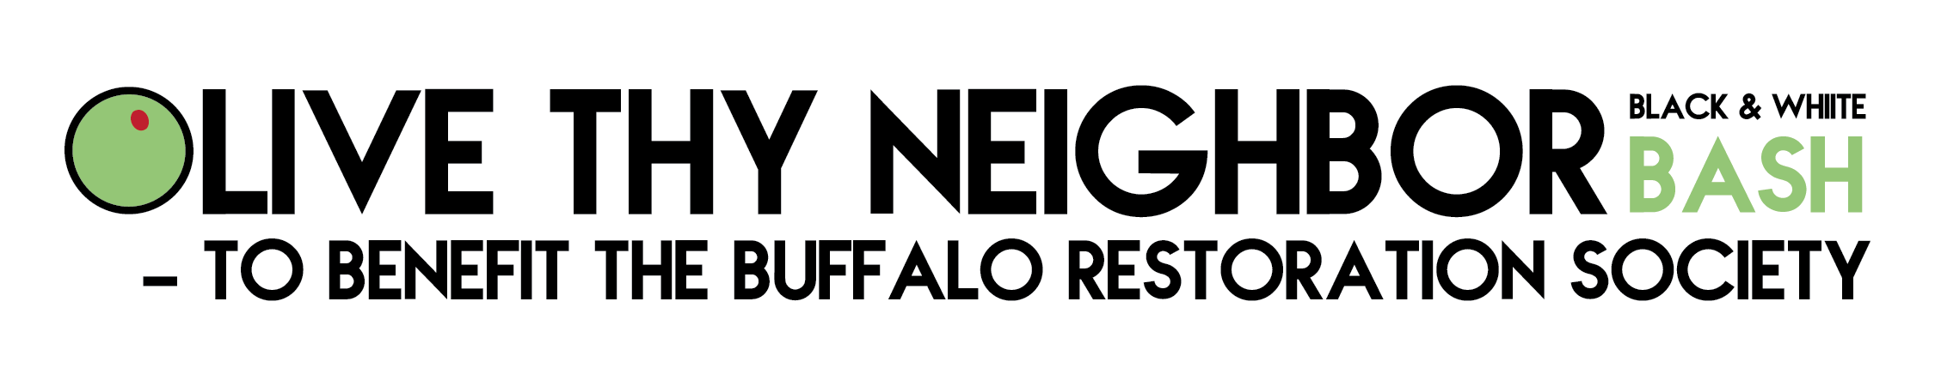

**ACE Employment and Empowerment Academy**

**327 Elm Street, 2nd Floor Buffalo, NY 14203**

**(716)884-5216**

CEO-Nancy Singh ext. 409

Executive Administrator- Kimberly Muoio ext. 402

Director of Rehabilitation Services- Fran Gullo ext. 407

EA Manager- Amanda Kopacz ext. 415

**Genesee ACE Employment**

**220 East Main Street Batavia, NY 14020**

**(585)343-9162**

Director of Programs - Genesee County

Gail McKee ext. 307

*Visit us at:*

Web site address

[www.rsiwny.org](http://www.rsiwny.org)

Facebook

[www.facebook.com/Restorationsocietyinc](http://www.facebook.com/Restorationsocietyinc)

**Administration Office, Housing Solutions**

**& Young Adult Clubhouse**

**66 Englewood Ave, Buffalo, NY 14214**

**(716)832-2141**

CFO-Sun-Ok King ext.213

COO-Kimberly Baughan ext. 215

Director of Homeless and Housing Services

Jean Bennett ext. 219

Director of Peer Services

Michelle Scheib ext. 230

Young Adult Recovery Club Manager

Marsha Tabb ext. 217

**Harbor House Resource Center**

**241 Genesee Street Buffalo, NY 14204**

**(716)842-4184**

Manager- Jacob Hoffman

Restoration Society, Inc.

66 Englewood Avenue

Buffalo, NY 14214

